**Approved Foreign Investments in the Philippines**

# Fourth Quarter 2015

### Summary

**Total Approved Foreign Investments (FI)**[1]**, Q4 and Annual 2015**

Total approved foreign investments (FI) in the fourth quarter of 2015 amounted to PhP 138.6 billion, higher by 45.6 percent from PhP 95.2 billion recorded in the same period in 2014. This represents the foreign investments approved by the seven investment promotion agencies (IPAs), namely: Board of Investments (BOI), Clark Development Corporation (CDC), Philippine Economic Zone Authority (PEZA), and Subic Bay Metropolitan Authority (SBMA) as well as the Authority of the Freeport Area of Bataan (AFAB), BOI-Autonomous Region of Muslim Mindanao (BOI-ARMM), and Cagayan Economic Zone Authority (CEZA). Meanwhile, total approved FI for the full year 2015 reached PhP 245.2 billion, an increase of 31.2 percent from PhP 187.0 billion in the previous year.

The top three prospective investing countries in the fourth quarter of 2015 include Japan, the Netherlands, and the United States of America (USA). Japan’s investment pledges reached PhP 39.4 billion or 28.5 percent share. The Netherlands and the USA committed PhP 37.0 billion and PhP 16.5 billion, or 26.7 percent and 11.9 percent of the total approved FI, respectively.

For the full year 2015, the Netherlands ranked first, committing PhP 82.7 billion or 33.7 percent. Japan and South Korea ranked second and third, with investments amounting to PhP 54.7 billion and PhP 23.2 billion, respectively.

Manufacturing received the largest amount for approved foreign investments during the quarter at PhP 95.8 billion or 69.1 percent. Electricity, Gas, Steam, and Air Conditioning Supply came in second with investment commitments valued at PhP 18.1 billion or 13.1 percent, followed by Administrative and Support Service Activities at PhP 14.3 billion or 10.3 percent.

These are also the top industries for the whole year 2015, with Manufacturing receiving the biggest commitments at PhP 134.6 billion or 54.9 percent. This is followed by Electricity, Gas, Steam and Air Conditioning Supply at PhP 46.5 billion or 19.0 percent and Administrative and Support Service Activities at PhP 22.9 billion or 9.3 percent.

About this report

# Inside

# Part I - Analysis

A. Approved Foreign Investments…………………….... 4 to 11

B. Approved Investments of Foreign and Filipino Nationals……………….. 12 to 19

C. Approved Investments in the

Information and Communications Technology (ICT) Industry………………..…….….. 20 to 21

D. Actual Foreign Direct Investments

in the Balance of Payments…… 22 to 23

###### Part II – Statistical Tables

###### Annexes

This report is the 74th of a series on quarterly statistics on foreign investments (FI) in the Philippines, integrating the quarterly statistical reports on FI submitted by the government’s investments promotion, administration and regulation agencies. It provides an analysis of the:

1. *Foreign investments* (FI)and *investments by Filipinos approved* by the Board of Investments (BOI), Clark Development Corporation (CDC), Philippine Economic Zone Authority (PEZA), Subic Bay Metropolitan Authority (SBMA), Authority of the Freeport Area of Bataan (AFAB), BOI-Autonomous Region of Muslim Mindanao (BOI-ARMM), and Cagayan Economic Zone Authority (CEZA). Approved foreign investments represent investment commitments or pledges by foreigners regardless of the percentage of ownership of the ordinary shares, which may be realized in the near future.
2. *Foreign direct investments* (FDI) in the Balance of Payments (BOP) as compiled by the Bangko Sentral ng Pilipinas (BSP). FDI refers to actual foreign direct investments in the BOP, with the foreign investors owning 10 percent or more of the ordinary shares or voting power or the equivalent.

Notes: (a) Starting with Q3 2013 Report, foreign investments approved and registered by the investment promotion agencies (IPAs) is termed “approved foreign investments,” replacing the term “approved foreign direct investments” used in the previous reports. This is to distinguish clearly the approved foreign investments which are only commitments or pledges from the foreign direct investments (FDI) which are actual investments being compiled by the BSP.

(b) Revisions in the previous quarters’ data are based on the updates provided by the investment promotion agencies. Annex A presents the technical notes on the data and compilation methodology while Annex B gives a brief background on the Foreign Investment Information System (FIIS) that generates the FI statistics presented in this report.

In terms of location, bulk of the approved foreign investments in the fourth quarter of 2015 would be intended to finance projects in Region IVA – CALABARZON, amounting to PhP 52.0 billion or 37.5 percent. Cordillera Administrative Region (CAR) stands to receive the second highest investments at PhP 26.3 billion or 19.0 percent, followed by the National Capital Region (NCR) at PhP 21.4 billion or 15.4 percent.

For the whole year 2015, Region IVA stands to receive the largest amount of foreign investments, valued at PhP 115.7 billion or 47.2 percent share. This is followed by NCR with pledges amounting to PhP 34.1 billion or 13.9 percent and CAR at PhP 26.3 billion or 10.7 percent.

#### Foreign Direct Investments (FDI) [2] in the Balance of Payments, October to November and January to November 2015

Foreign direct investments (FDI) in the Balance of Payments (BOP) as compiled by the Bangko Sentral ng Pilipinas (BSP) recorded net inflows of US$ 914.0 million from October to November of 2015. The amount is 8.4 percent higher than US$ 843.0 million in the previous year. Meanwhile, net FDI inflows for the period January to November of 2015 amounted to US$ 5.5 billion, lower by 3.4 percent from US$ 5.6 billion during the same period in 2014.

In peso terms, FDI in the BOP for October to November of 2015 posted a net inflow of PhP 41.0 billion, up by 8.4 percent from PhP 37.8 billion in 2014. For the first 11 months in 2015, FDI in the BOP recorded a net inflow of PhP 242.4 billion, posting 3.3 percent decline from a net inflow of PhP 250.7 billion in the same period in 2014.

**Approved Investments of Foreign and Filipino Nationals, Q4 and Annual 2015**

Approved investments of foreign and Filipino nationals reached PhP 332.3 billion in the fourth quarter of 2015, up by 43.7 percent from previous year’s PhP 231.2 billion. Filipino nationals continued to dominate investments approved during the quarter, sharing 58.3 percent or PhP 193.7 billion worth of pledges. Among the industries, Electricity, Gas, Steam and Air Conditioning Supply would receive the highest investments at PhP 152.3 billion or 45.8 percent of the total approved investments.

For the whole year 2015, the total approved investments of foreign and Filipino nationals amounted to PhP 686.9 billion, 9.1 percent lower than PhP 755.9 billion committed a year ago. The highest investments would go to Electricity, Gas, Steam and Air Conditioning Supply at PhP 256.2 billion or 37.3 percent of the total approved investments.

**Projected Employment from Approved Investments of Foreign and Filipino Nationals, Q4 and Annual 2015**

Projects of foreign and Filipino investors approved by the seven IPAs in the fourth quarter of 2015 are expected to generate a total of 38,906 jobs, lower by 36.7 percent from the previous year’s projected employment of 61,424. Out of the total anticipated jobs for the period, 79.1 percent would come from projects with foreign interest. Among the industries, administrative and support service activities is expected to have the most number of jobs to be generated at 14,588.

For the year 2015, projected employment from approved investments reached 169,075 jobs, down by 40.3 percent from the 283,354 jobs expected a year ago. The most number of jobs expected to be generated would be for the Administrative and Support Service Activities at 51,290.

**Approved Investments of Foreign and Filipino Nationals in Information and Communications Technology (ICT), Q4 and Annual 2015**

Investments in Information and Communications Technology (ICT) proposed by foreign and Filipino nationals in Q4 2015 went up by 17.2 percent to PhP 21.4 billion, from PhP 25.8 billion committed in the fourth quarter of 2014. Share of the projects in ICT stood at 6.4 percent of the total approved investments during the quarter. Foreign nationals remained as the major source of investment pledges in ICT, committing PhP 17.7 billion worth of investments or a share of 83.0 percent.

Proposed investments in ICT for the whole year of 2015 totaled PhP 39.7 billion.

**Part I – ANALYSIS**

1. **Approved Foreign Investments (FI)**

**A.1 Total Approved FI**

**A.1.1 Fourth Quarter 2015**

FI applications approved in the fourth quarter of 2015 by BOI, CDC, PEZA, SBMA, AFAB, BOI-ARMM, and CEZA amounted to PhP 138.6 billion, up by 45.6 percent from PhP 95.2 billion recorded in the fourth quarter of 2014.

**Figure 1a**

**Total Approved Foreign Investments**

**Fourth Quarter, 2014 and 2015**

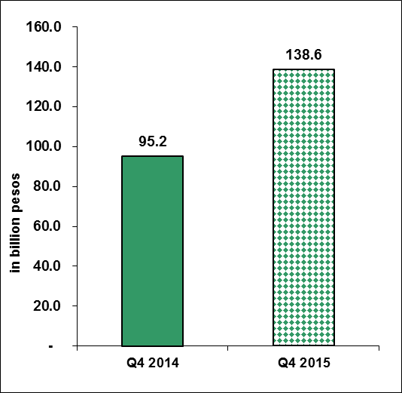

Sources of data: AFAB, BOI, BOI-ARMM, CDC, CEZA, PEZA, SBMA

PEZA accounted for majority of the FI approvals in the fourth quarter of 2015, cutting in PhP 116.6 billion or 84.1 percent of the total commitments for the quarter. Meanwhile, BOI accounted for the second largest amount of FI approval at PhP 17.7 billion or 12.8 percent. The other IPAs jointly accounted for 3.1 percent of the total approved FI.

Among the IPAs, CDC registered the fastest year-on-year growth, increasing by 362.6 percent to PhP 2.1 billion from PhP 449.7 million in 2014. Pledges from SBMA grew by 201.5 percent to PhP 2.0 billion from PhP 646.8 million while PEZA-approved FI grew by 66.1 percent from PhP 70.2 billion a year ago. On the other hand, FI approved by AFAB, BOI, and CEZA declined by 8.7 percent, 24.6 percent, and 66.5 percent, respectively (Table A and Part II – Table 1b).

**Table A**

**Total Approved FI by Investment Promotion Agency**

**(in million pesos)**

**Fourth Quarter, 2014 and 2015**



Sources of data: AFAB, BOI, BOI-ARMM, CDC, CEZA, PEZA, SBMA

**A.1.2 Annual 2015**

Total approved FI for 2015 reached PhP 245.2 billion, up by 31.2 percent from PhP 187.0 billion in the preceding year. Around 68.9 percent of the total FI applications was coursed through PEZA with pledges amounting to PhP 168.9 billion. BOI accounted for the second largest share of FI approvals with 24.3 percent or PhP 59.5 billion while CDC accounted for 4.0 percent or PhP 9.7 billion. The other IPAs contributed 2.9 percent of the total FI for the year 2015.

**Figure 1b**

**Total Approved Foreign Investments**

**Annual, 2014 and 2015**

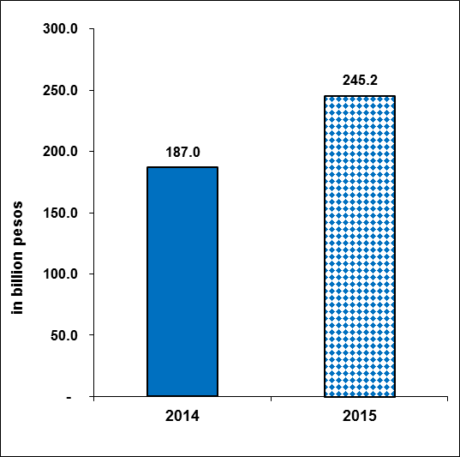

Sources of data: AFAB, BOI, BOI-ARMM, CDC, CEZA, PEZA, SBMA

Investment pledges from BOI-ARMM increased by five folds in 2015 to PhP 3.2 billion, from PhP 579.6 million. Commitments from CEZA, BOI, PEZA, and AFAB registered double-digit growth rates of 74.2 percent, 61.3 percent, 32.5 percent, and 13.2 percent, respectively. Approved foreign investments from CDC grew by 8.0 percent. On the other hand, pledges from SBMA declined by 77.1 percent in 2015 (Table B and Part II – Table 1c).

**Table B**

**Total Approved FI by Investment Promotion Agency**

**(in million pesos)**

**Annual, 2014 and 2015**



Sources of data: AFAB, BOI, BOI-ARMM, CDC, CEZA, PEZA, SBMA

Figure 2 below shows the series of quarterly approved FI from Q1 1996 to Q4 2015.

**Figure 2**

**Total Approved Foreign Investments (in billion pesos)**

**First Quarter 1996 to Fourth Quarter 2015**

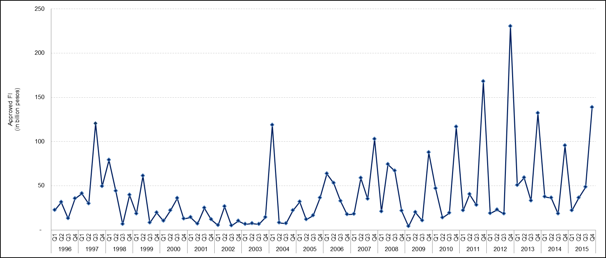

Sources of data: AFAB, BOI, BOI-ARMM, CDC, CEZA, PEZA, SBMA

**A.2 Top Prospective Investing Countries**

**A.2.1 Fourth Quarter 2015**

Japan led the list of top countries as it intended to invest PhP 39.4 billion worth of investments, accounting for 28.5 percent of the total FI during the period. Majority of the investments are intended to finance projects in Manufacturing.

Joining Japan as top sources of FI are the Netherlands, with PhP 37.0 billion investment pledges or a share of 26.7 percent and USA, cutting in 11.9 percent or PhP 16.5 billion. Investments pledged from the Netherlands are mostly intended to finance projects in the Administrative and Support Service Activities and Manufacturing. FI from USA would fund projects in Accommodation and Food Service Activities (Figure 3a and Part II - Table 2a).

**Figure 3a**

**Total Approved FI by Country of Investor**

**Fourth Quarter 2015**

. 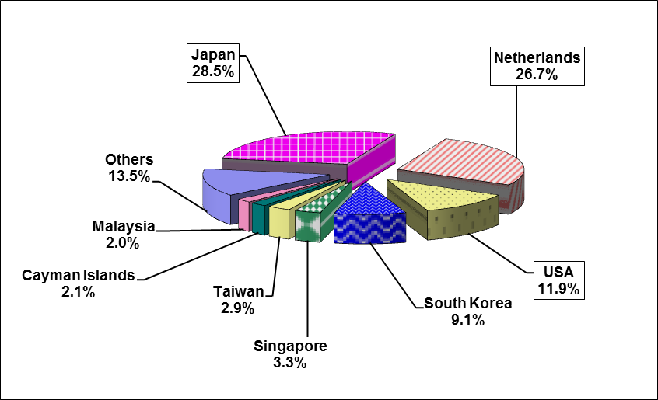

Sources of data: AFAB, BOI, BOI-ARMM, CDC, CEZA, PEZA, SBMA

**A.2.2 Annual 2015**

For the full year 2015, the Netherlands topped the list of investing countries, committing PhP 82.7 billion or 33.7 percent of the total FI applications. This is followed by Japan, accounting for PhP 54.7 billion or 22.3 percent, and South Korea, cutting in PhP 23.2 billion or 9.4 percent share. Investments from the Netherlands are mainly intended to fund projects in Manufacturing and Electricity, Gas, Steam, and Air Conditioning Supply. Investments from Japan would be in Manufacturing while pledges from South Korea are mostly intended to finance projects in Accommodation and Food Service Activities. Investment pledges from the the three countries registered increases at 152.3 percent for Netherlands, 53.4 percent for Japan and 457.5 percent for South Korea (Figure 3b and Part II – Table 2b).

**Figure 3b**

**Total Approved FI by Country of Investor**

**Annual 2015**

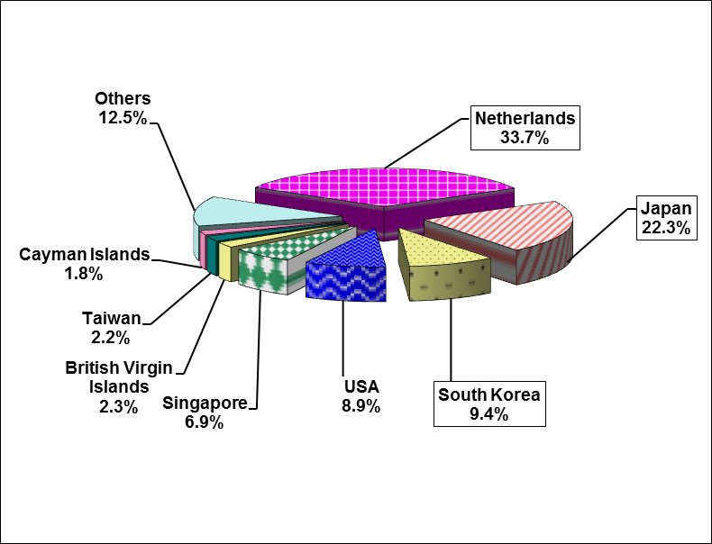

Sources of data: AFAB, BOI, BOI-ARMM, CDC, CEZA, PEZA, SBMA

**A.3 Top Industries for Approved Foreign Investments**

**A.3.1 Fourth Quarter 2015**

More than half, or 69.1 percent, of the approved foreign investments in the fourth quarter of 2015 were intended to fund projects in the Manufacturing industry. Investments in the sector grew by 75.9 percent to PhP 95.8 billion, from PhP 54.4 billion in the same period in the previous year. Projects in Electricity, Steam, Gas, and Air Conditioning Supply would receive the second largest amount of foreign investments at PhP 18.1 billion with a share of 13.1 percent. The amount is six times higher than PhP 2.8 billion committed to the industry in Q4 2014. Ranked third is Administrative and Support Service Activities, with investments valued at PhP 14.3 billion or 10.3 percent (Table C and Part II – Table 3a).

**Table C**

**Total Approved FI by Industry[3] (in million pesos)**

**Fourth Quarter, 2014 and 2015**



Sources of data: AFAB, BOI, BOI-ARMM, CDC, CEZA, PEZA, SBMA

**A.3.2 Annual 2015**

Majority of the foreign investment commitments in 2015 were intended to finance projects in Manufacturing as it stands to receive PhP 134.6 billion or 54.9 percent of the total approved FI. Pledges in the said industry increased by 22.9 percent from PhP 109.5 billion in the same period in 2014. Electricity, Gas, Steam and Air Conditioning Supply came in second with investment commitments valued at PhP 46.5 billion or 19.0 percent. Next is Administrative and Support Service Activities amounting to PhP 22.9 billion or 9.3 percent share. Proposed investments in Electricity, Gas, Steam, and Air Conditioning Supply grew by seven folds during the period while FI for Administrative and Support Service Activities declined by 23.1 percent (Table D and Part II – Table 3b).

**Table D**

**Total Approved FI by Industry (in million pesos)**

**Annual, 2014 and 2015**



Sources of data: AFAB, BOI, BOI-ARMM, CDC, CEZA, PEZA, SBMA

**A.4. Total Approved FI by Region**

**A.4.1 Fourth Quarter 2015**

Bulk of the approved foreign investments in the fourth quarter of 2015 would be intended to finance projects located in Region IVA – CALABARZON, amounting to PhP 52.0 billion or 37.5 percent share. Foreign investments in Region IVA grew by 13.7 percent compared to the same period a year ago at PhP 45.8 billion. The regions with the second and third largest amount of investments are Cordillera Administrative Region (CAR) with PhP 26.3 billion or 19.0 percent and the National Capital Region (NCR) with PhP 21.4 billion or 15.4 percent (Figure 4a and Part II – Table 4a).

Most of the investments in Region IVA are intended for projects in Real Estate Activities and Manufacturing. For CAR, the ventures would be mostly in Manufacturing while for NCR, most of the prospective projects would be in Administrative and Support Service Activities.

**Figure 4a**

**Total Approved FI by Region (in million pesos)**

**Fourth Quarter 2015**

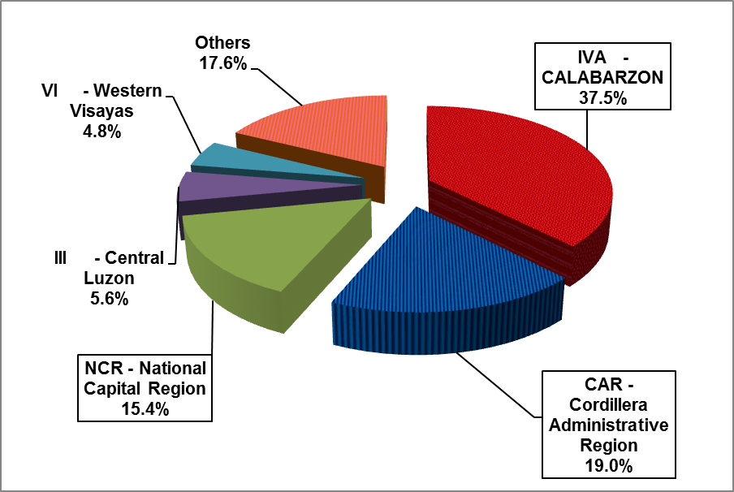

Sources of data: AFAB, BOI, BOI-ARMM, CDC, CEZA, PEZA, SBMA

**A.4.2 Annual 2015**

Region IVA – CALABARZON is set to receive almost half or 47.2 percent of the foreign investment commitments in the whole year of 2015 as FI in the region reached PhP 115.6 billion. Investment commitments intended for Region IVA grew by 32.6 percent.

The second largest amount of FI during the period is intended for NCR, accounting for 13.9 percent or PhP 34.1 billion. Meanwhile, CAR posted the third largest share of FI at PhP 26.3 billion, 10.7 percent of the total approved investments. FI approvals for NCR declined by 34.4 percent while commitments from CAR grew by 17 folds (Figure 4b and Part II – Table 4b). Majority of the investments in Region IVA and CAR are intended for projects in Manufacturing. For NCR, the ventures would be mostly in Administrative and Support Service Activities.

**Figure 4b**

**Total Approved FI by Region (in million pesos)**

**Annual 2015**

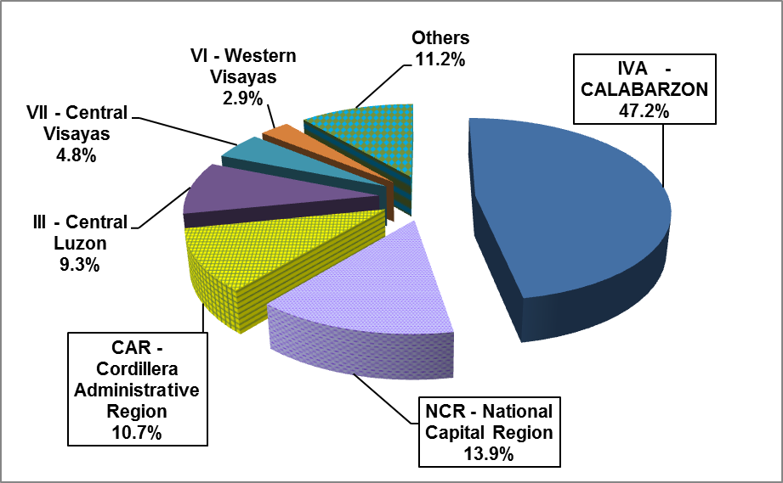

Sources of data: AFAB, BOI, BOI-ARMM, CDC, CEZA, PEZA, SBMA

**A.5 Projected Employment from Approved FI**

**A.5.1 Fourth Quarter 2015**

FI projects approved by the seven IPAs in the fourth quarter of 2015 are expected to generate 30,791 jobs, 29.4 percent lower than 43,638 prospective jobs in the same period in 2014 (Part II – Table 5a). Foreign investments coursed through PEZA are expected to generate the most number of jobs at 14,642, accounting for 47.6 percent of the total projected employment for the quarter. BOI-approved FI projects accounted for 8,210 jobs or 26.7 percent. CDC is expected to generate 3,273 jobs or 10.6 percent while AFAB is expected to generate 3,202 jobs or 10.4 percent. SBMA and CEZA had minimal combined share of 4.8 percent in terms of job generation.

Projected employment from SMBA-approved investments increased by 10 folds in the fourth quarter of 2015, the fastest year-on-year growth among the IPAs. Expected jobs from projects approved by CDC grew by three folds while jobs from AFAB-approved projects grew by 11.2 percent. On the other hand, prospective jobs from projects approved by BOI, CEZA, and PEZA declined by 40.1 percent, 22.3 percent, and 42.5 percent, respectively.

**A.5.2 Annual 2015**

Projected employment from approved FI in 2015 stood at 118,698 jobs, down by 48.9 percent compared to previous year’s 232,475 prospective jobs.

FI projects approved by PEZA are expected to generate the most number of jobs at 77,829 or 65.6 percent of the total projected employment. This is followed by BOI with 19,892 jobs or 16.8 percent and CDC with 10,134 jobs or 8.5 percent (Part II – Table 5b).

BOI-ARMM registered the fastest increase in expected employment at 121.0 percent. Projected employment from SBMA increased by 82.2 percent while expected jobs from CEZA grew by 41.0 percent. On the other hand, projected employment from AFAB, BOI, CDC, and PEZA registered declines of 21.6 percent, 37.6 percent, 87.7 percent, and 29.0 percent, respectively.

**B. Approved Investments of Foreign and Filipino Nationals**

**B.1 Total Approved Investments of Foreign and Filipino Nationals**

**B.1.1 Fourth Quarter 2015**

The approved investments of Filipino and foreign nationals amounted to PhP 332.3 billion, increasing by 43.7 percent from PhP 231.2 billion in the fourth quarter of 2014. Filipino nationals accounted for majority of the investments approved during the quarter, supplying 58.3 percent or PhP 193.7 billion (Figure 5a and Part II - Table 7a).

The bulk of the investment commitments of Filipino and foreign nationals for the quarter were coursed through BOI and PEZA with a combined share of 98.2 percent. Approved investments through BOI, which accounts for 52.5 percent, amounted to PhP 174.4 billion, 88.1 percent higher than PhP 92.7 billion approved a year ago. Meanwhile, investment pledges coursed through PEZA grew by 15.7 percent to PhP 151.9 billion from PhP 131.3 billion in the previous year (Part II – Table 6a).

**Figure 5a**

**Total Approved Investments of Foreign and Filipino Nationals**

**Fourth Quarter, 2014 and 2015**

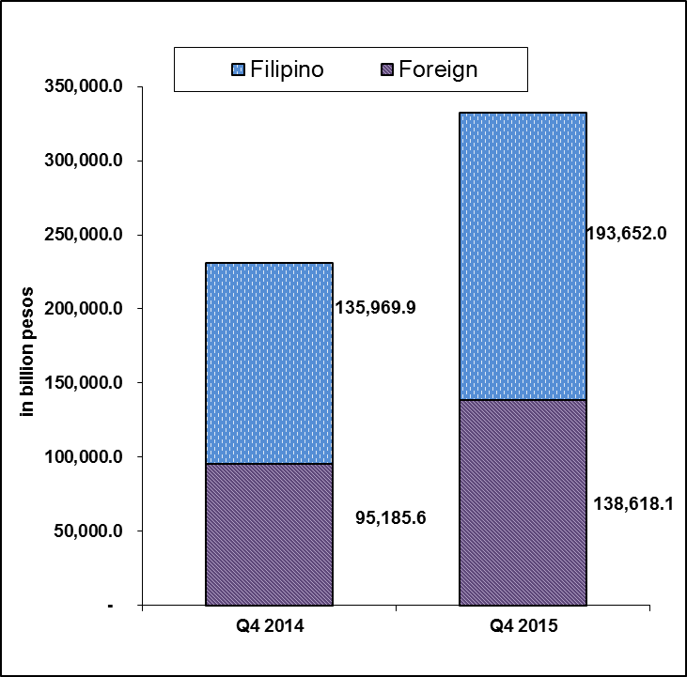

Sources of data: AFAB, BOI, BOI-ARMM, CDC, CEZA, PEZA, SBMA

**B.1.2 Annual 2015**

Investment commitments from both Filipino and foreign nationals amounted to PhP 686.9 billion for the year 2015, a decline of 9.1 percent from PhP 755.9 billion in 2014 (Figure 5b and Part II – Table 6b). Of the total amount during the year, 64.3 percent of the approved investments came from Filipino investors with PhP 441.7 billion worth of pledges (Figure 5b and Part II – Table 7b).

Investment pledges coursed through BOI accounted for 53.4 percent of the total investments in the amount of PhP 366.7 billion. Investment commitments from PEZA totaled PhP 285.0 billion or 41.5 percent. Meanwhile, investments approved by CDC and BOI ARMM accounted for 1.8 percent or PhP 12.6 billion and 1.0 percent or PhP 6.6 billion, respectively . The other IPAs had collective pledges of PhP 15.9 billion or 2.3 percent of the total investments (Part II – Table 7b).

**Figure 5b**

**Total Approved Investments of Foreign and Filipino Nationals**

**Annual, 2014 and 2015**

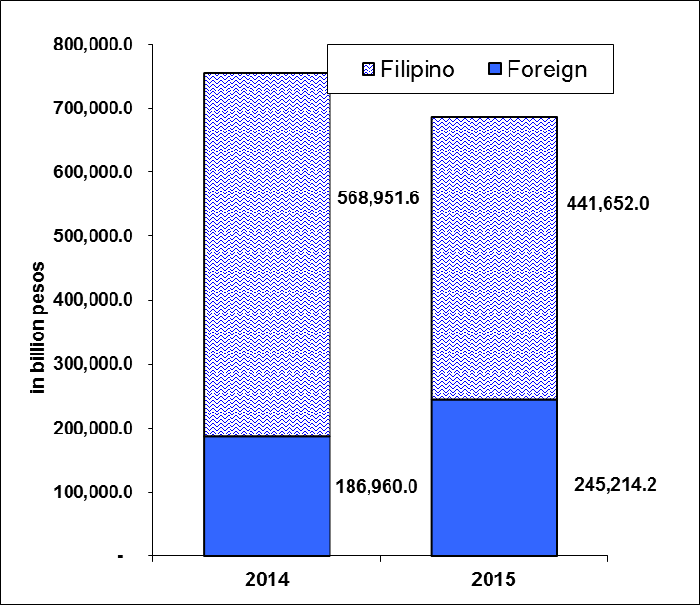

Sources of data: AFAB, BOI, BOI-ARMM, CDC, CEZA, PEZA, SBMA

**B.2 Total Approved Investments of Foreign and Filipino Nationals by Industry**

**B.2.1 Fourth Quarter 2015**

Electricity, Gas, Steam and Air Conditioning Supply topped the list of industries during the fourth quarter of 2015 as it stands to receive PhP 152.3 billion or 45.8 percent of the total investment pledges of foreign and Filipino nationals (Figure 6a and Part II - Tables 3a and 8a).

Investments in Manufacturing ranked second as it accounted for 33.2 percent share or PhP 110.4 billion, followed by Real Estate Activities, receiving 9.8 percent or PhP 32.5 billion (Figure 6a and Part II – Table 8a).

Figure 6a

Total Approved Investments of Foreign and Filipino Nationals, by Industry

**Fourth Quarter 2015**

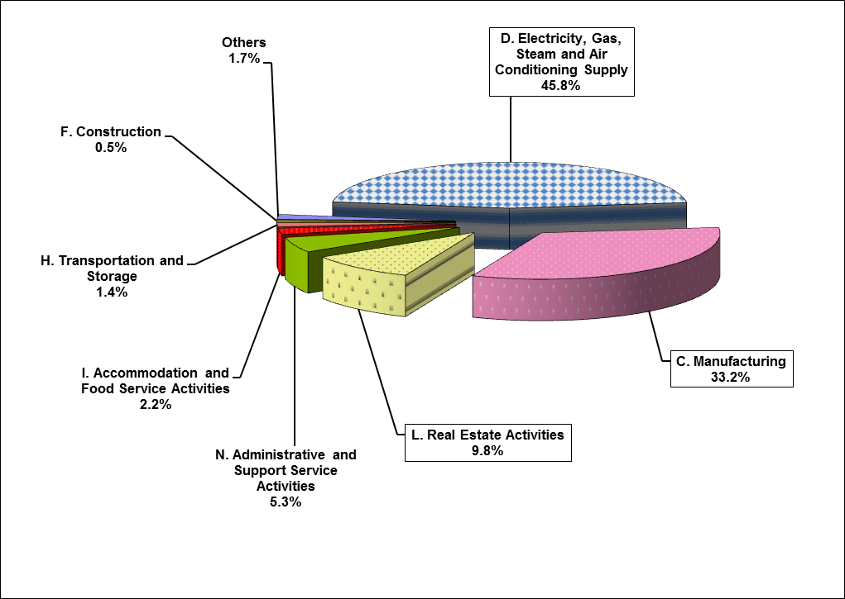

Sources of data: AFAB, BOI, BOI-ARMM, CDC, CEZA, PEZA, SBMA

**B.2.2 Annual 2015**

Electricity, Gas, Steam and Air Conditioning Supply topped the list of recipients of investment intentions from both foreign and Filipino nationals in 2015 as it stands to receive PhP 256.2 billion and 37.3 percent of total investments.

Manufacturing came in second at PhP 170.9 billion or 24.9 percent share, followed by Real Estate Activities at PhP 136.9 billion or 19.9 percent. Potential investments in Electricity, Gas, Steam and Air Conditioning Supply increased by 20.0 percent, while investments in Manufacturing and Real Estate Activities declined by 8.2 percent and 20.7 percent, respectively (Figure 6b and Part II – Table 8b).

**Figure 6b**

Total Approved Investments of Foreign and Filipino Nationals, by Industry

**Annual 2015**

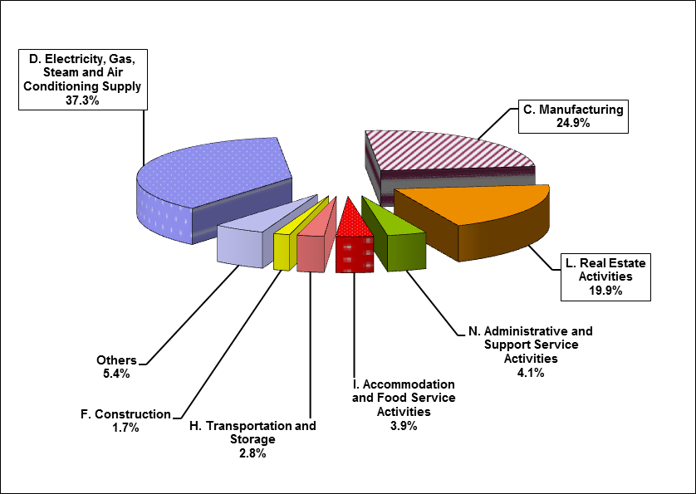

**B.3. Total Approved Investments of Foreign and Filipino Nationals by Region**

**B.3.1 Fourth Quarter 2015**

Bulk of the approved investments from foreign and Filipino nationals in the fourth quarter of 2015 would be intended to finance projects located in Region IVA - CALABARZON. Total investment pledges for the said region amounts to PhP 139.2 billion, or 41.9 percent share. Approved investments in Region IVA increased by 65.8 percent compared to same period a year ago at PhP 84.0 billion. The regions with the second and third largest amount of investments for Q4 2015 were Region VI - Western Visayas with PhP 48.3 billion or 14.5 percent and the National Capital Region (NCR) with PhP 43.5 billion or 13.1 percent, respectively (Figure 7a and Part II – Table 9a).

Majority of the investments in Region IVA are intended for projects in Electricity, Gas, Steam and Air Conditioning Supply and Manufacturing. Investments in Region VI would be mostly for projects in the Electricity, Gas, Steam, and Air Conditioning Supply while investments in NCR are mostly intended for Manufacturing.

**Figure 7a**

**Total Approved Investments of Foreign and Filipino Nationals by Region (in million pesos)**

**Fourth Quarter 2015**

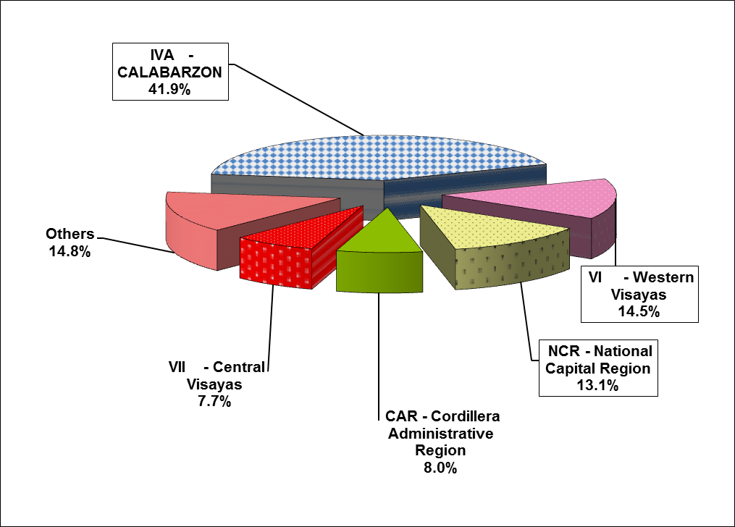

Sources of data: AFAB, BOI, BOI-ARMM, CDC, CEZA, PEZA, SBMA

**B.3.2 Annual 2015**

For 2015, Region IVA – CALABARZON stands to receive the largest amount of investments from foreign and Filipino nationals, pledging PhP 271.3 billion or 39.5 percent share. Investment commitments intended for the region grew by 21.1 percent during the period. The National Capital Region (NCR) received the second largest amount of total investment pledges during the period, accounting for 17.2 percent or PhP 118.1 billion. Region VI – Western Visayas received the third largest share of commitments at PhP 75.0 billion or 10.9 percent of the total pledges. Investment approvals for NCR registered a decline of 45.9 percent while pledges from Region VI went up by 187.2 percent (Figure 7b and Part II – Table 9b).

Majority of the investments in Region IVA are intended for projects in Electricity, Gas, Steam and Air conditioning Supply and Manufacturing. For NCR, the ventures would be mostly in Real Estate Activities and Administrative and Support Service Activities. Meanwhile, investments in Region VI are mostly intended for projects in Real Estate Activities and Electricity, Gas, Steam, and Air Conditioning Supply.

**Figure 7b**

**Total Approved Investments of Foreign and Filipino Nationals by Region (in million pesos)**

**Annual 2015**

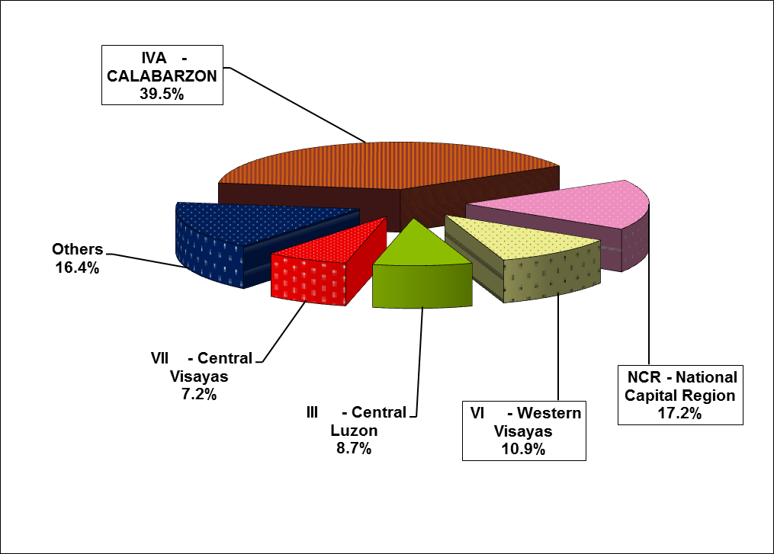

Sources of data: AFAB, BOI, BOI-ARMM, CDC, CEZA, PEZA, SBMA

**B.4 Projected Employment from Approved Investments of Foreign and Filipino Nationals**

**B.4.1 Fourth Quarter 2015**

Total projects of foreign and Filipino investors approved by the seven IPAs for the fourth quarter of 2015 are expected to generate 38,906 jobs, a decline of 36.7 percent from previous year’s projected employment of 61,424. Out of these anticipated jobs, 79.1 percent would come from projects with foreign interest.

Projects registered through PEZA posted the largest number of prospective employment at 16,179, contributing 41.6 percent of the total expected jobs for the period. BOI-approved projects recorded 12,813 potential jobs, with a share of 32.9 percent while pledges coursed through CDC are expected to generate 4,509 jobs or 11.6 percent. Meanwhile, the combined investments from AFAB, BOI-ARMM, CEZA, and SBMA are expected to generate 5,405 jobs (Figure 8a and Part II – Table 10a).

**Figure 8a**

**Projected Employment**

**Fourth Quarter, 2014 and 2015**

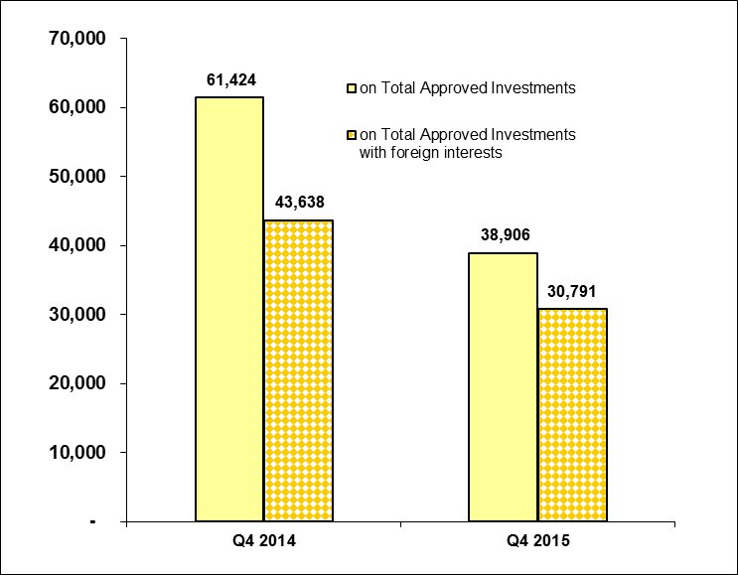

Sources of data: AFAB, BOI, BOI-ARMM, CDC, CEZA, PEZA, SBMA

**B.4.2 Annual 2015**

For the year 2015, a total of 169,075 jobs are expected to be generated from approved investments of foreign and Filipino nationals, 40.3 percent lower compared to 283,354 jobs in the preceding year. Almost half or 49.4 percent of jobs would come from investment pledges coursed through PEZA followed by BOI with 58,252 jobs or 34.5 percent. Other IPAs would have a combined share of 16.1 percent of the total jobs expected (Figure 8b and Part II – Table 10b).

The number of potential jobs for investments coursed through BOI ARMM, CEZA, and SBMA grew by 61.9 percent, 39.7 percent and 53.6 percent, respectively. Projected employment declined for the rest of the IPAs during the period.

**Figure 8b**

**Projected Employment**

**Annual, 2014 and 2015**

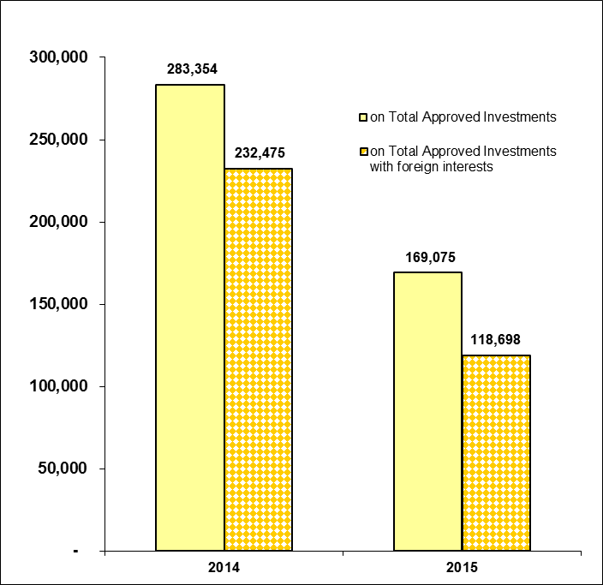

Sources of data: AFAB, BOI, BOI-ARMM, CDC, CEZA, PEZA, SBMA

**B.5 Projected Employment from Approved Investments of Foreign and Filipino Nationals by Industry**

**B.5.1 Fourth Quarter 2015**

In terms of projected employment by industry, Administrative and Support Service Activities is expected to have the most number of jobs to be generated at 14,588 in the fourth quarter of 2015. Next industries are Manufacturing at 11,108 jobs and Real Estate Activities at 4,828 jobs. However, compared to fourth quarter of 2014, the said industries registered declines in projected employment at 19.4 percent for Administrative and Support Services, 52.2 percent for Manufacturing, and 52.1 percent for Real Estate Activities (Table E).

**Table E**

**Projected Employment from Approved Investments by Industry**

**Fourth Quarter, 2014 and 2015**



Sources of data: AFAB, BOI, BOI-ARMM, CDC, CEZA, PEZA, SBMA

**B.5.2 Annual 2015**

Of the 169,075 projected jobs in 2015 from prospective ventures of foreign and Filipino investors, Administrative and Support Service Activities (51,290), Manufacturing (48,751 jobs), and Real Estate Activities (25,115 jobs) are foreseen to supply the bulk of projected employment with shares of 30.3 percent, 28.8 percent, and 14.9 percent, respectively. These industries, however, registered declines of 9.0 percent, 43.9 percent and 74.9 percent, respectively, compared to the previous year. The rest of the potential jobs, totaling 43,879 jobs or 26.0 percent, are expected to be provided by the other industries (Table F).

**Table F**

**Projected Employment from Approved Investments by Industry**

**Annual, 2014 and 2015**



Sources of data: AFAB, BOI, BOI-ARMM, CDC, CEZA, PEZA, SBMA

**C. Approved Investments in the Information and Communications Technology (ICT) Industry**

**C.1 Total Approved FI in ICT**

##### C.1.1 Fourth Quarter 2015

Approved foreign investments in the ICT in the fourth quarter of 2015 amounted to PhP 17.7 billion, down by 17.2 percent compared to the previous year. ICT represents 12.8 percent of the total foreign investment pledges. PEZA consistently receives the bulk of investment pledges in ICT, with a share of 90.8 percent. However, PEZA investments in ICT declined by 21.9 percent to PhP 16.1 billion, from PhP 20.6 billion in the previous year. (Part II – Table 11a).

# C.1.2 Annual 2015

Potential foreign investments in ICT in 2015 decreased by 15.0 percent, amounting to PhP 28.2 billion from previous year’s PhP 33.2 billion. FI in ICT coursed through PEZA amounted to PhP 25.4 billion, lower by 19.9 percent compared to PhP 31.7 billion a year ago. Likewise, BOI registered declines in FI in ICT at 50.5 percent during the period (Part II – Table 11b).

FI in ICT would account for 11.5 percent of the total FI registered for the year 2015 (Part II – Tables 10b and 11b).

**C.2 Total Approved Investments in ICT of Foreign and Filipino Nationals**

##### C.2.1 Fourth Quarter 2015

Pledges in ICT investments made by foreign and Filipino nationals in the fourth quarter of 2015 amounted to PhP 21.4 billion, down by 17.2 percent from PhP 25.8 billion in Q4 2014. Foreign nationals remained as the major source of investment pledges in ICT, committing 83.0 percent (Table G and Part II – Table 11a).

**Table G**

**Total Approved Investments in ICT by Foreign and Filipino Nationals**

**Fourth Quarter, 2014 and 2015**

**(in million pesos)**



Sources of data: AFAB, BOI, BOI-ARMM, CDC, CEZA, PEZA, SBMA

* 1. **C.2.2 Annual 2015**

Total ICT investments made by foreign and Filipino nationals during the year reached PhP 39.7 billion, the same amount registered in 2014 (Part II - Table 11b). ICT investments from Filipino nationals grew by 77.0 percent to PhP 11.5 billion, accounting for 28.9 percent of the total approved projects in ICT (Part II - Tables 11b and 5b).

**C.3 Total Approved Investments in ICT of Foreign and Filipino Nationals by ICT Sub-Industry**

##### C.3.1 Fourth Quarter 2015

IT services remained as the main recipient of investment intentions in ICT of foreign and Filipino nationals during the quarter as it stands to receive PhP 17.9 billion or 83.7 percent of total ICT projects. Information and communication accounted for 9.4 percent or PhP 2.0 billion while manufacturing would receive PhP 1.5 billion (Part II – Table 13a).

# C.3.2 Annual 2015

Of the total investments in ICT in 2015, 71.3 percent or PhP 28.3 billion would go to IT services. Information and communication came in second at PhP 9.9 billion, contributing a share of 25.0 percent while manufacturing and trade account for PhP 1.5 billion and PhP 24.0 million, respectively (Part II – Table 13b).

**C.4 Projected Employment from Approved Investments in ICT of Foreign and Filipino Nationals by ICT Sub-Industry**

**C.4.1 Fourth Quarter 2015**

Approved investments of foreign and Filipino nationals in ICT are anticipated to create 14,864 jobs in the fourth quarter of 2015, lower by 39.2 percent compared to 24,442 jobs expected in Q4 2014. IT services is expected to supply 13,468 jobs or 90.6 percent of total employment in ICT while 1,396 jobs are seen to be generated from information and communication (Table H and Part II – Table 14a).

Projected employment from ICT industry accounted for 38.2 percent of total jobs expected from the investment projects of foreign and Filipino nationals approved in the fourth quarter of 2015 (Part II – Tables 14a and 10a).

**Table H**

**Projected Employment from Approved Investments in ICT by ICT Sub-industry**

**Fourth Quarter, 2014 and 2015**



Sources of data: AFAB, BOI, BOI-ARMM, CDC, CEZA, PEZA, SBMA

# C.4.2 Annual 2015

Projected employment from ICT projects during the year totaled 59,786 jobs, 12.5 percent lower than 68,342 jobs expected in 2014. IT services is expected to absorb 49,100 jobs or 82.1 percent of the expected employment while 10,677 jobs or 17.9 percent would be from information and communication. Trade is expected to create 9 jobs (Part II – Table 14b).

1. **Actual Foreign Direct Investments (FDI) in the Balance of Payments[4]**

**D.1 Total BOP FDI in US Dollars and Philippine Pesos[5]**

**D.1.1 October to November 2015**

As reported by the BSP, net Foreign Direct Investments (FDI) inflows for October to November 2015 reached US$ 914.0 million, 8.4 percent higher than the net inflows of US$ 843.0 million recorded in the same period in 2014. Equity other than reinvestment of earnings was valued at US$ 325.0 million. On the other hand, reinvestment of earnings and net debt instruments recorded US$ 115.0 million and US$ 474.0 million, respectively, during the period (Part II – Figure 9a and Table 15a).

**Figure 9a**

**Balance of Payments FDI (in million US$)**

**October to November, 2014 and 2015**

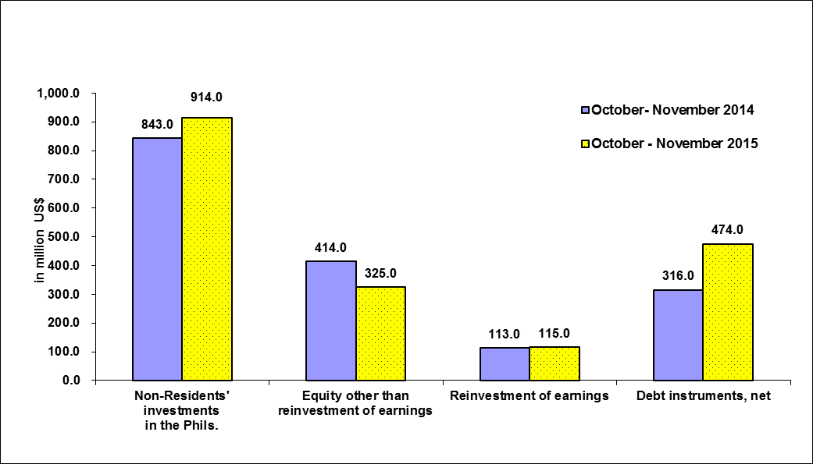

Source of data: BSP

In peso terms, FDI net inflows for the period October to November of 2015 amounted to PhP 41.0 billion, 8.4 percent higher compared to PhP 37.8 billion in the preceding year (Part II – Table 16a).

**D.1.2 January to November 2015**

Net FDI inflows from January to November of 2015 amounted to US$ 5.5 billion, 3.4 percent lower compared to US$ 5.6 billion recorded in the same period in 2014. Equity other than reinvestment of earnings reached US$ 1.8 billion, 13.6 percent higher compared to US$ 1.6 billion in the previous year (Part II – Figure 9b and Table 15b).

Net inflows of reinvestment of earnings reached US$ 692.0 million, a decline of 9.5 percent compared to the previous year. Meanwhile, net debt instruments registered an inflow of US$ 3.0 billion during the period.

**Figure 9b**

**Balance of Payments FDI (in million US$)**

**January to November, 2014 and 2015**

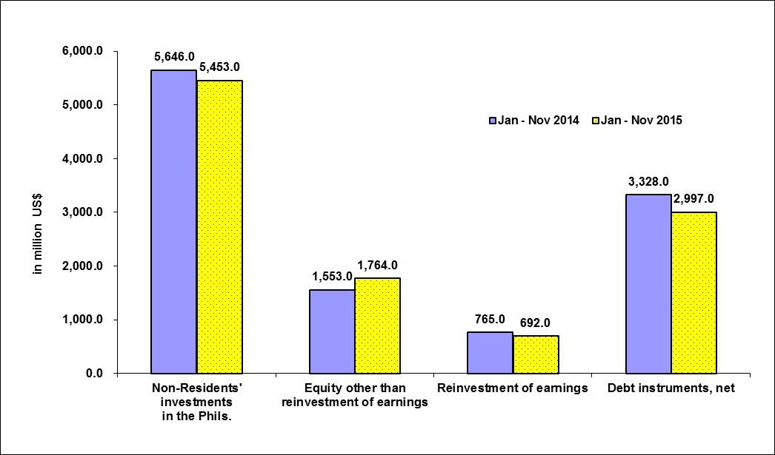

Source of data: BSP

In peso terms, FDI in the BOP for January to November 2015 recorded a net inflow of PhP 242.4 billion, declining by 3.3 percent from a net inflow of PhP 250.7 billion in the same period in 2014 (Part II – Table 16b).

1. Approved FI represents the amount of proposed contribution or share of foreigners to various projects in the country as approved and registered by the IPAs. This consists of equity, loans and reinvested earnings. (See Annex A – Technical Notes)
2. FDI refers to actual foreign direct investments in the BOP, with the foreign investors owning 10 percent or more of the ordinary shares or voting power or the equivalent. Data refers to net FDI flows consisting of non-residents’ equity capital placements less non-residents’ equity capital withdrawals plus reinvested earnings plus net intercompany loans.
3. Industry classification is based on the 2009 Philippine Standard Industrial Classification (PSIC).
4. BSP media release dated February 11, 2016
5. Using monthly average buying and selling rates downloaded from BSP website