**Approved Foreign Investments in the Philippines**

# Fourth Quarter 2016

### Summary

**Total Approved Foreign Investments (FI)**[1]**, Q4 and Annual 2016**

Total approved foreign investments (FI) in the fourth quarter of 2016 amounted to   
PhP 125.7 billion, 9.3 percent lower compared to PhP 138.6 billion approved in the same period in 2015. This comprised the foreign investments approved by the seven investment promotion agencies (IPAs), namely: the Authority of the Freeport Area of Bataan (AFAB), Board of Investments (BOI), BOI-Autonomous Region of Muslim Mindanao (BOI-ARMM), Clark Development Corporation (CDC), Cagayan Economic Zone Authority (CEZA), Philippine Economic Zone Authority (PEZA), and Subic Bay Metropolitan Authority (SBMA). For annual 2016, total approved investments reached PhP 219.0 billion. This was a decline of 10.7 percent from PhP 245.2 billion in 2015

The top three investing countries in the fourth quarter of 2016 were Netherlands, Australia, and the United States of America (USA). Investment from the Netherlands reached PhP 34.9 billion or 27.7 percent share. Australia committed PhP 31.8 billion or 25.3 percent, while USA pledged PhP 20.1 billion or 16.0 percent of the total approved FI. Total pledges from the three countries contributed 69.1 percent to the total approved FI.

For the full year 2016, the Netherlands ranked first with investment commitments of   
PhP 49.4 billion or 22.6 percent share. Australia and USA, which ranked second and third, pledged to invest PhP 32.4 billion and PhP 31.4 billion, respectively.

Manufacturing received the biggest portion of approved FI in Q4 2016 amounting to   
PhP 66.8 billion or 53.2 percent share. Electricity, Gas, Steam, and Air Conditioning Supply came in second with investment commitments valued at PhP 32.0 billion or 25.4 percent. This is followed by Administrative and Support Service Activities at PhP 11.8 billion or 9.4 percent.

The same industries topped the list of would be recipients of approved FI in 2016. Manufacturing received the highest investment commitments at PhP 95.9 billion or 43.8 percent share. This was followed by Electricity, Gas, Steam and Air Conditioning Supply at PhP 55.6 billion or   
25.4 percent, and Administrative and Support Service Activities at PhP 25.7 billion or   
11.8 percent.

About this report

# Inside

# Part I - Analysis

A. Approved Foreign Investments…………………….... 4 to 11

B. Approved Investments of Foreign and Filipino Nationals……………….. 12 to 19

C. Approved Investments in the

Information and Communications Technology (ICT) Industry………………..…….….. 20 to 21

D. Actual Foreign Direct Investments

in the Balance of Payments…… 21 to 23

###### Part II – Statistical Tables

###### Annexes

This report is the 78th of a series on quarterly statistics on foreign investments (FI) in the Philippines, integrating the quarterly statistical reports on FI submitted by the government’s investments promotion, administration and regulation agencies. It provides an analysis of the:

1. *Foreign investments* (FI)and *investments by Filipinos approved* by the Board of Investments (BOI), Clark Development Corporation (CDC), Philippine Economic Zone Authority (PEZA), Subic Bay Metropolitan Authority (SBMA), Authority of the Freeport Area of Bataan (AFAB), BOI-Autonomous Region of Muslim Mindanao (BOI-ARMM), and Cagayan Economic Zone Authority (CEZA);
2. *Foreign direct investments* (FDI) in the Balance of Payments (BOP) as compiled by the Bangko Sentral ng Pilipinas (BSP).

Approved foreign investments represent investment commitments and pledges by foreigners regardless of the percentage of ownership of the ordinary shares, which may be realized in the near future while FDI refers to actual foreign investments generated, with the foreign investors owning 10 percent or more of the ordinary shares.

Annex A presents the technical notes on the data and compilation methodology while Annex B gives a brief background on the Foreign Investment Information System (FIIS) that generates the FI statistics presented in this report.

In terms of location, bulk of the approved foreign investments in the fourth quarter of 2016 would be intended to finance projects in Region IVA – CALABARZON amounting to PhP 68.2 billion or 54.2 percent. This was followed by Cordillera Administrative Region (CAR) at PhP 22.2 billion or 17.7 percent, and the National Capital Region (NCR) at PhP 19.2 billion or 15.3 percent.

For the whole year 2016, Region IVA positioned to receive the largest amount of foreign investments, valued at PhP 94.3 billion or 43.1 percent share. This was followed by NCR with pledges amounting to PhP 37.6 billion or 17.2 percent, and CAR at PhP 24.7 billion or   
11.3 percent.

#### Foreign Direct Investments (FDI) [2] in the Balance of Payments, October to November and January to November 2016

Foreign direct investments (FDI) in the Balance of Payments (BOP) as compiled by the Bangko Sentral ng Pilipinas (BSP) recorded net inflows of US$ 1.1 billion from October to November of 2016. This amount was 25.8 percent higher than the previous year’s net inflows of   
US$ 872.9 million. Meanwhile, net FDI inflows for the period January to November of 2016 amounted to US$ 7.0 billion, 25.3 percent higher than US$ 5.6 billion net FDI inflows during the same period in 2015.

In peso terms, FDI in the BOP for October to November of 2016 posted net inflows of   
PhP 49.3 billion, up by 25.8 percent from PhP 39.2 billion in 2015. For the first 11 months in 2016, FDI in the BOP recorded net inflows of PhP 310.3 billion or an increase of 26.0 percent from net inflows of PhP 246.3 billion in the same period in 2015.

**Approved Investments of Foreign and Filipino Nationals, Q4 and Annual 2016**

Approved investments of foreign and Filipino nationals amounted to PhP 274.8 billion in the fourth quarter of 2016, down by 17.3 percent from previous year’s PhP 332.3 billion. Filipino nationals continued to dominate investments approved in Q4 2016. This comprised 54.3 percent or PhP 149.1 billion worth of total pledges. Among the industries, Manufacturing would receive the highest investments at PhP 92.5 billion or 33.7 percent of the total approved investments.

For the whole year 2016, the total approved investments of foreign and Filipino nationals amounted to PhP 686.0 billion, 0.1 percent lower than PhP 686.9 billion committed a year ago. The highest investments, amounting to PhP 215.9 billion or 31.5 percent of the total approved investments, would go to Electricity, Gas, Steam and Air Conditioning Supply.

**Projected Employment from Approved Investments of Foreign and Filipino Nationals, Q4 and Annual 2016**

Total projects of foreign and Filipino investors approved by the seven IPAs in the fourth quarter of 2016 are expected to generate a total of 49,054 jobs, higher by 26.1 percent from the previous year’s projected employment of 38,906. Out of the total anticipated jobs for the period,   
66.7 percent would come from projects with foreign investments. Among the industries, Manufacturing was expected to have the most number of jobs to be generated at 18,562.

For the year 2016, projected employment from approved investments reached 195,971 jobs, up by 15.9 percent from the 169,075 jobs expected a year ago. The most number of jobs expected to be generated would be for the Administrative and Support Service Activities at 61,218.

**Approved Investments of Foreign and Filipino Nationals in Information and Communications Technology (ICT), Q4 and Annual 2016**

Investment proposals in Information and Communications Technology (ICT) by foreign and Filipino nationals in Q4 2016 amounted to PhP 15.3 billion, lower by 28.3 percent, from   
PhP 21.4 billion committed in the fourth quarter of 2015. The ICT projects accounted for   
5.6 percent of Q4 2016 total approved investments. Foreign nationals remained as the major source of investment pledges in ICT at PhP 14.3 billion or a share of 93.5 percent.

Proposed investments in ICT for the whole year of 2016 totaled PhP 30.7 billion.

**Part I – ANALYSIS**

1. **Approved Foreign Investments (FI)**

**A.1 Total Approved FI**

**A.1.1 Fourth Quarter 2016**

FI applications approved in the fourth quarter of 2016 by BOI, CDC, PEZA, SBMA, AFAB,   
BOI-ARMM, and CEZA amounted to PhP 125.7 billion, down by 9.3 percent from   
PhP 138.6 billion recorded in the fourth quarter of 2015.

**Figure 1a**

**Total Approved Foreign Investments**

**Fourth Quarter, 2015 and 2016**



Sources of data: AFAB, BOI, BOI-ARMM, CDC, CEZA, PEZA, SBMA

PEZA accounted for majority of the FI approvals in the fourth quarter of 2016, sharing   
PhP 84.9 billion or 67.5 percent of the total commitments for the quarter. Meanwhile, BOI accounted for the second largest amount of FI approvals at PhP 39.8 billion or 31.7 percent. The other IPAs jointly accounted for 0.8 percent of the total approved FI.

All IPAs, except BOI, recorded declines in its approved investments in Q4 2016. While   
BOI-approved FI grew by 124.7 percent, SBMA, CEZA, CDC and PEZA decreased by   
99.8 percent, 77.1 percent, 52.8 percent and 27.2 percent, respectively (Table A and   
Part II – Table 1b).

**Table A**

**Total Approved FI by Investment Promotion Agency (in million pesos)**

**Fourth Quarter, 2015 and 2016**



Sources of data: AFAB, BOI, BOI-ARMM, CDC, CEZA, PEZA, SBMA

**A.1.2 Annual 2016**

Total approved FI for 2016 amounted to PhP 219.0 billion, down by 10.7 percent from the previous year’s PhP 245.2 billion. More than half or 55.3 percent of the total FI applications was coursed through PEZA with pledges amounting to PhP 121.2 billion. BOI accounted for the second largest share of FI approvals at PhP 89.4 billion or 40.8 percent, followed by SBMA at PhP 4.8 billion or 2.2 percent. The other IPAs contributed 1.7 percent of the total FI in 2016.

**Figure 1b**

**Total Approved Foreign Investments**

**Annual, 2015 and 2016**



Sources of data: AFAB, BOI, BOI-ARMM, CDC, CEZA, PEZA, SBMA

Only SBMA and BOI recorded increases in approved FI in 2016. SBMA-approved FI grew by 70.5 percent, while BOI-approved FI increased by 50.2 percent. On the other hand, pledges from CDC and CEZA declined by 76.3 percent and 76.2 percent, respectively. FI from   
BOI-ARMM, AFAB, and PEZA likewise declined by 67.7 percent, 64.9 percent, and   
28.2 percent, respectively (Table B and Part II – Table 1c).

**Table B**

**Total Approved FI by Investment Promotion Agency (in million pesos)**

**Annual, 2015 and 2016**



Sources of data: AFAB, BOI, BOI-ARMM, CDC, CEZA, PEZA, SBMA

Figure 2 shows the series of quarterly approved FI from Q1 1996 to Q4 2016.

**Figure 2**

**Total Approved Foreign Investments (in billion pesos)**

**First Quarter 1996 to Fourth Quarter 2016**

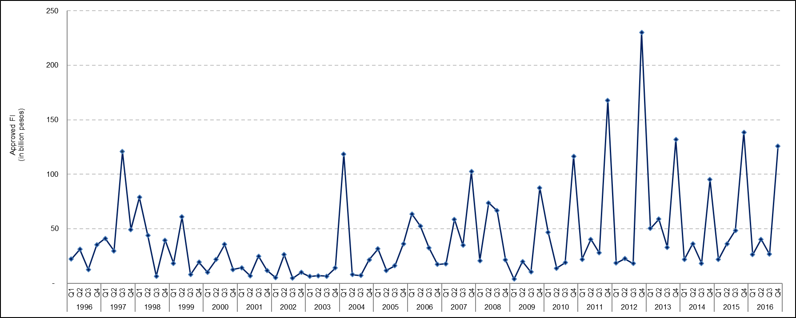

Sources of data: AFAB, BOI, BOI-ARMM, CDC, CEZA, PEZA, SBMA

**A.2 Top Prospective Investing Countries**

**A.2.1 Fourth Quarter 2016**

The Netherlands topped the list of prospective investing countries at PhP 34.9 billion intended investments, accounting for 27.7 percent of the total FI in Q4 2016. Investments from the Netherlands, however, declined by 5.7 percent from its record of Php 37.0 billion a year ago. Majority of the investments were intended to finance projects in Manufacturing.

Next to the Netherlands in the list of top FI sources were Australia and USA, with investment pledges of PhP 31.8 billion or 25.3 percent and PhP 20.1 billion or 16.0 percent, respectively. Investments pledged by Australia were mostly intended to finance projects in the Electricity, Gas, Steam and Air Conditioning Supply. Approved FI from USA would fund projects in Manufacturing and Administrative and Support Service Activities (Figure 3a and   
Part II - Table 2a).

**Figure 3a**

**Total Approved FI by Country of Investor**

**Fourth Quarter 2016**

. 

Sources of data: AFAB, BOI, BOI-ARMM, CDC, CEZA, PEZA, SBMA

**A.2.2 Annual 2016**

For the full year 2016, the Netherlands also topped the list of investing countries, with commitments worth PhP 49.4 billion or 22.6 percent of the total FI applications. This was followed by Australia, accounting for PhP 32.4 billion or 14.8 percent, and USA, cutting in   
PhP 31.4 billion or 14.3 percent share. Investments from the Netherlands and Australia were mainly intended to fund projects in Manufacturing and Electricity, Gas, Steam and Air Conditioning Supply, while investments from the USA were mainly intended to finance projects in Manufacturing and Administrative and Support Service Activities. Total investment pledges from the Netherlands, however, was lower by 40.2 percent compared to its level a year ago. On the other hand, FI from Australia increased by more than 60 times, while USA expanded by 44.6 percent (Figure 3b and Part II – Table 2b).

**Figure 3b**

**Total Approved FI by Country of Investor**

**Annual 2016**



Sources of data: AFAB, BOI, BOI-ARMM, CDC, CEZA, PEZA, SBMA

**A.3 Top Industries for Approved Foreign Investments**

**A.3.1 Fourth Quarter 2016**

More than half or 53.2 percent of the approved foreign investments in the fourth quarter of 2016 were intended to fund projects in the Manufacturing industry. Investments in this industry, however, declined to PhP 66.8 billion or by 30.2 percent from PhP 95.8 billion in   
Q4 2015. Projects in Electricity, Steam, Gas, and Air Conditioning Supply would receive the second largest amount of intended foreign investments at PhP 32.0 billion or 25.4 percent share. Approved FI for this industry, on one hand, grew by 76.7 percent from PhP 18.0 billion record a year ago. Ranked third was Administrative and Support Service Activities, with investments valued at PhP 11.8 billion or 9.4 percent (Table C and Part II – Table 3a).

**Table C**

**Total Approved FI by Industry[3] (in million pesos)**

**Fourth Quarter, 2015 and 2016**



Sources of data: AFAB, BOI, BOI-ARMM, CDC, CEZA, PEZA, SBMA

**A.3.2 Annual 2016**

Bulk of the foreign investment commitments in 2016 were intended to finance projects in Manufacturing as the industry stood to receive PhP 95.9 billion or 43.8 percent of the total approved FI. Pledges in this industry, however, declined by 28.7 percent from   
PhP 134.6 billion in the same period in 2015. Electricity, Gas, Steam and Air Conditioning Supply came in second with investment commitments valued at PhP 55.6 billion or   
25.4 percent. Next was Administrative and Support Service Activities amounting to   
PhP 25.7 billion or 11.8 percent share. Proposed investments in Electricity, Gas, Steam, and Air Conditioning Supply grew by 19.7 percent during the period, while approved FI for Administrative and Support Service Activities was higher by 12.4 percent (Table D and   
Part II – Table 3b).

**Table D**

**Total Approved FI by Industry (in million pesos)**

**Annual, 2015 and 2016**



Sources of data: AFAB, BOI, BOI-ARMM, CDC, CEZA, PEZA, SBMA

**A.4. Total Approved FI by Region**

**A.4.1 Fourth Quarter 2016**

More than half or 54.2 percent of the approved foreign investments in the fourth quarter of 2016 would be intended to finance projects located in Region IVA – CALABARZON, amounting to PhP 68.2 billion. Foreign investments in Region IVA grew by 31.0 percent from a record of   
PhP 52.0 billion during same period a year ago. The regions with the second and third largest amount of investments were Cordillera Administrative Region (CAR) with   
PhP 22.2 billion or 17.7 percent, and the National Capital Region (NCR) with PhP 19.2 billion or 15.3 percent (Figure 4a and Part II – Table 4a).

Most of the investments in Region IVA were intended for projects in Manufacturing and Electricity, Gas, Steam and Air Conditioning Supply. For CAR, the ventures would be mostly in Manufacturing, while for NCR most of the prospective projects would be in Administrative and Support Service Activities.

**Figure 4a**

**Total Approved FI by Region (in million pesos)**

**Fourth Quarter 2016**



Sources of data: AFAB, BOI, BOI-ARMM, CDC, CEZA, PEZA, SBMA

**A.4.2 Annual 2016**

Region IVA – CALABARZON was set to receive bulk of the foreign investment commitments in the whole year of 2016, as FI in this region reached PhP 94.3 billion or 43.1 percent share. Investment commitments intended for Region IVA, however, declined by 18.4 percent from its level in the previous year.

The second largest FI during the period, amounting to PhP 37.6 billion or 17.2 percent share, was intended for NCR. Meanwhile, CAR posted the third largest share of FI at   
PhP 24.7 billion, 11.3 percent of the total approved investments. FI approvals for NCR grew by 10.1 percent, while commitments for CAR declined by 6.2 percent (Figure 4b and   
Part II – Table 4b). Majority of the investments in Region IVA and CAR were intended for projects in Manufacturing. For NCR, the ventures would be mostly in Administrative and Support Service Activities.

**Figure 4b**

**Total Approved FI by Region (in million pesos)**

**Annual 2016**

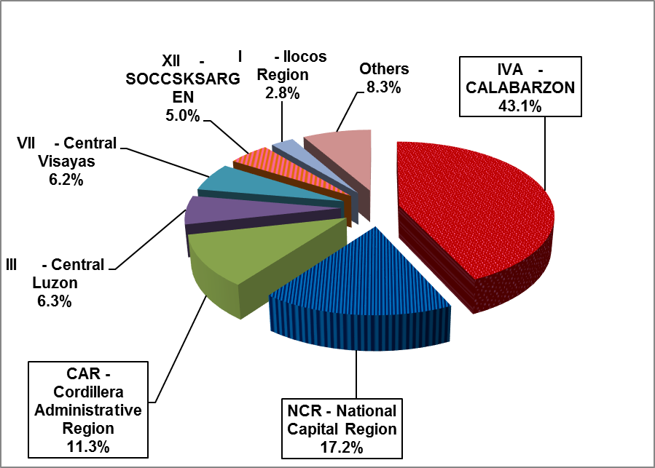

Sources of data: AFAB, BOI, BOI-ARMM, CDC, CEZA, PEZA, SBMA

**A.5 Projected Employment from Approved FI**

**A.5.1 Fourth Quarter 2016**

FI projects approved by the seven IPAs in the fourth quarter of 2016 were expected to generate 32,740 jobs, 6.3 percent higher than 30,791 prospective jobs in the same quarter in 2015   
(Part II – Table 5a). Foreign investments coursed through PEZA were expected to generate the most number of jobs at 16,530, accounting for 50.5 percent of the total projected employment for the quarter. BOI-approved FI projects accounted for 10,957 jobs or   
33.5 percent share. The rest of the IPAs accounted for 16.0 percent of the total projected employment.

Projected employment from CDC-approved investments increased by 58.5 in the fourth quarter of 2016, the fastest year-on-year growth among the IPAs. Expected jobs from projects approved by BOI grew by 33.5 percent, while jobs from PEZA-approved projects grew by   
12.9 percent. On the other hand, prospective jobs from projects approved by CEZA and SBMA declined by 81.6 percent and 99.2 percent, respectively (Part II – Table 5a).

**A.5.2 Annual 2016**

Projected employment from approved FI in 2016 stood at 153,913 jobs, up by 29.7 percent compared to previous year’s 118,698 prospective jobs.

FI projects approved by PEZA were expected to generate the most number of jobs at 96,677 or 62.8 percent of the total projected employment. This was followed by BOI with 40,959 jobs or 26.6 percent share, and CDC with 10,967 jobs or 7.1 percent share (Part II – Table 5b).

BOI registered the fastest increase in expected employment at 105.9 percent. Projected employment from PEZA increased by 24.2 percent, while expected jobs from CDC grew by   
8.2 percent. On the other hand, the rest of the IPAs recorded declines in the projected employment (Part II – Table 5b).

**B. Approved Investments of Foreign and Filipino Nationals**

**B.1 Total Approved Investments of Foreign and Filipino Nationals**

**B.1.1 Fourth Quarter 2016**

The approved investments of Filipino and foreign nationals amounted to PhP 274.8 billion, a decline of 17.3 percent from Q4 2015 record of PhP 332.3 billion. Filipino nationals accounted for the majority of the approved investments which amounted to PhP 149.1 billion or   
54.3 percent (Figure 5a and Part II - Table 7a).

The bulk of the investment commitments of Filipino and foreign nationals for the quarter was coursed through BOI and PEZA at a combined share of 99.2 percent. Approved investments through BOI amounted to PhP 155.6 billion or 56.6 percent share. This amount, however, was 10.8 percent lower than PhP 174.4 billion approved a year ago. Similarly, investment pledges coursed through PEZA, which accounted for 42.6 percent of the total investments, declined by 23.0 percent from its previous year’s record of PhP 151.9 billion (Part II – Table 6a).

**Figure 5a**

**Total Approved Investments of Foreign and Filipino Nationals**

**Fourth Quarter, 2015 and 2016**

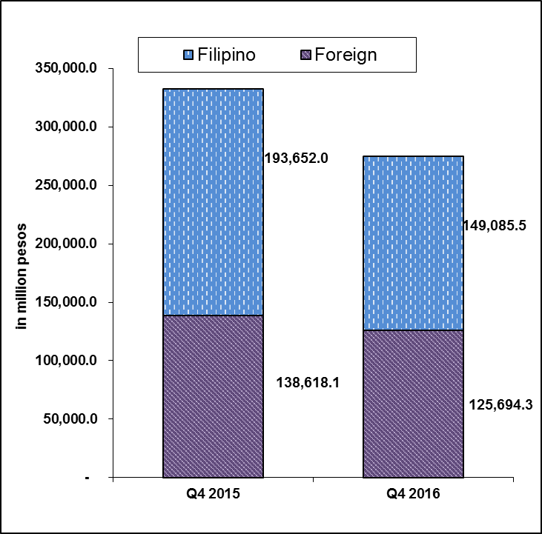

Sources of data: AFAB, BOI, BOI-ARMM, CDC, CEZA, PEZA, SBMA

**B.1.2 Annual 2016**

Investment commitments from both Filipino and foreign nationals in 2016 slightly lowered by   
0.1 percent to PhP 686.0 billion from PhP 686.9 billion in 2015 (Figure 5b and   
Part II – Table 6b). Out of the Php 686.0 billion investment commitments in 2016,   
PhP 466.9 billion worth of pledges or 68.1 percent were from Filipino investors   
(Figure 5b and Part II – Table 7b).

Investment pledges coursed through BOI accounted for 64.4 percent of the total investments in the amount of PhP 442.0 billion. Investment commitments from PEZA totaled   
PhP 218.2 billion or 31.8 percent of the total investments for 2016. Meanwhile, investments approved by SBMA and CDC amounted to PhP 9.3 billion or 1.4 percent and PhP 8.1 billion or 1.2 percent, respectively. The rest of the IPAs had collective pledges of PhP 8.3 billion or   
1.2 percent of the total investments (Part II – Table 6b).

**Figure 5b**

**Total Approved Investments of Foreign and Filipino Nationals**

**Annual, 2015 and 2016**

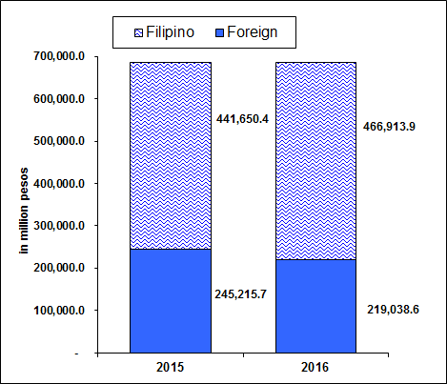

Sources of data: AFAB, BOI, BOI-ARMM, CDC, CEZA, PEZA, SBMA

**B.2 Total Approved Investments of Foreign and Filipino Nationals by Industry**

**B.2.1 Fourth Quarter 2016**

Manufacturing topped the list of FI recipient industries in the fourth quarter of 2016 as it stood to receive PhP 92.5 billion or 33.7 percent of the total investment pledges of foreign and Filipino nationals (Figure 6a and Part II – Tables 8a). Investments in Manufacturing, however, declined by 16.2 percent compared the previous year’s PhP 110.4 billion.

Electricity, Gas, Steam, and Air Conditioning Supply ranked second as it posted   
PhP 75.9 billion or 27.6 percent share; followed by Real Estate Activities at PhP 45.0 billion or 16.4 percent of the total investments for the period (Figure 6a and Part II – Table 8a).

Figure 6a

Total Approved Investments of Foreign and Filipino Nationals, by Industry

**Fourth Quarter 2016**



Sources of data: AFAB, BOI, BOI-ARMM, CDC, CEZA, PEZA, SBMA

**B.2.2 Annual 2016**

Electricity, Gas, Steam and Air Conditioning Supply topped the list of recipients of investment intentions from both foreign and Filipino nationals in 2016, as it stood to receive   
PhP 215.9 billion or 31.5 percent of total investments. Investments in the industry, however, declined year-on-year by 15.7 percent.

Real Estate Activities at PhP 143.6 billion or 20.9 percent came next in the list; followed by Manufacturing with PhP 136.5 billion or 19.9 percent share. Potential investments from 2015 to 2016, increased by 4.5 percent in Real Estate Activities, while investments in Manufacturing declined by 20.1 percent (Figure 6b and Part II – Table 8b).

**Figure 6b**

Total Approved Investments of Foreign and Filipino Nationals, by Industry

**Annual 2016**



Sources of data: AFAB, BOI, BOI-ARMM, CDC, CEZA, PEZA, SBMA

**B.3. Total Approved Investments of Foreign and Filipino Nationals by Region**

**B.3.1 Fourth Quarter 2016**

Bulk of the approved investments from foreign and Filipino nationals in the fourth quarter of 2016 would be intended to finance projects located in Region IVA - CALABARZON. Total investment pledges for this region amounted to PhP 118.5 billion or 43.1 percent share. Approved investments in Region IVA declined by 14.9 percent compared to last year’s record of PhP 139.2 billion. The regions with the second and third largest amount of investments for Q4 2016 were the National Capital Region (NCR) with PhP 45.8 billion or 16.7 percent and the Cordillera Administrative Region PhP 44.2 billion or 16.1 percent, respectively   
(Figure 7a and Part II – Table 9a).

Majority of the investments in Region IVA and CAR were intended for projects in Manufacturing and Electricity, Gas, Steam and Air Conditioning Supply. Investments in NCR would be mostly for projects in Real Estate.

**Figure 7a**

**Total Approved Investments of Foreign and Filipino Nationals by Region (in million pesos)**

**Fourth Quarter 2016**



Sources of data: AFAB, BOI, BOI-ARMM, CDC, CEZA, PEZA, SBMA

**B.3.2 Annual 2016**

For 2016, Region IVA – CALABARZON stood to receive the largest amount of investments from foreign and Filipino nationals at the amount of PhP 181.7 billion or 26.5 percent share. Investment commitments intended for the region, however, declined by 33.0 percent during the period. The National Capital Region (NCR) received the second largest amount of total investment pledges during the period, accounting for 23.2 percent or PhP 159.0 billion.   
Region III – Central Luzon received the third largest share of commitments at PhP 89.9 billion or 13.1 percent of the total pledges. Investment approvals for NCR registered an increase of 34.7 percent while pledges from Region III went up by 49.8 percent (Figure 7b and   
Part II – Table 9b).

Majority of the investments in Region IVA were intended for projects in Manufacturing and Electricity, Gas, Steam and Air Conditioning Supply. For NCR, the ventures would be mostly in Real Estate. Meanwhile, investments in Region III were mostly intended for projects in Electricity, Gas, Steam, and Air Conditioning Supply.

**Figure 7b**

**Total Approved Investments of Foreign and Filipino Nationals by Region (in million pesos)**

**Annual 2016**



Sources of data: AFAB, BOI, BOI-ARMM, CDC, CEZA, PEZA, SBMA

**B.4 Projected Employment from Approved Investments of Foreign and Filipino Nationals**

**B.4.1 Fourth Quarter 2016**

Total projects of foreign and Filipino investors approved by the seven IPAs for the fourth quarter of 2016 were expected to generate 49,054 jobs, an increase of 26.1 percent from previous year’s projected employment of 38,906. Out of these anticipated jobs, 66.7 percent would come from projects with foreign interest.

Projects registered through BOI posted the largest number of prospective employment at 20,918, contributing 42.6 percent of the total expected jobs for the period. PEZA-approved projects recorded 16,762 potential jobs, with a share of 34.2 percent while pledges coursed through CDC were expected to generate 11,227 jobs or 22.9 percent   
(Figure 8a and Part II – Table 10a).

**Figure 8a**

**Projected Employment**

**Fourth Quarter, 2015 and 2016**

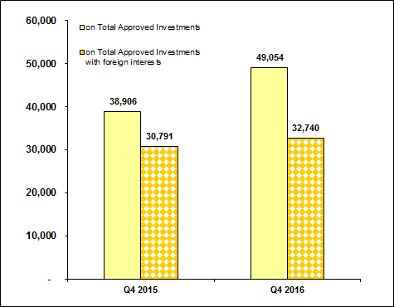

Sources of data: AFAB, BOI, BOI-ARMM, CDC, CEZA, PEZA, SBMA

**B.4.2 Annual 2016**

For the year 2016, a total of 195,971 jobs were expected to be generated from approved investments of foreign and Filipino nationals, 15.9 percent higher compared to 169,075 jobs in the preceding year. About half or 50.4 percent of jobs would come from investment pledges coursed through PEZA, with 98,883 expected jobs followed by BOI with 67,634 jobs or   
34.5 percent. Other IPAs would have a combined share of 15.1 percent of the total jobs expected (Figure 8b and Part II – Table 10b).

**Figure 8b**

**Projected Employment**

**Annual, 2015 and 2016**



Sources of data: AFAB, BOI, BOI-ARMM, CDC, CEZA, PEZA, SBMA

**B.5 Projected Employment from Approved Investments of Foreign and Filipino Nationals by Industry**

**B.5.1 Fourth Quarter 2016**

In terms of projected employment by industry, Manufacturing was expected to have the most number of jobs to be generated at 18,562 in the fourth quarter of 2016. Next to Manufacturing were: Real Estate at 10,595 jobs and Administrative and Support Service Activities at   
10,168 jobs. Projected employment for Manufacturing increased by 67.1 percent while employment in the Real Estate grew by more than double. On the other hand, prospective job for Administrative and Support Service Activities declined by 30.3 percent (Table E).

**Table E**

**Projected Employment from Approved Investments by Industry**

**Fourth Quarter, 2015 and 2016**

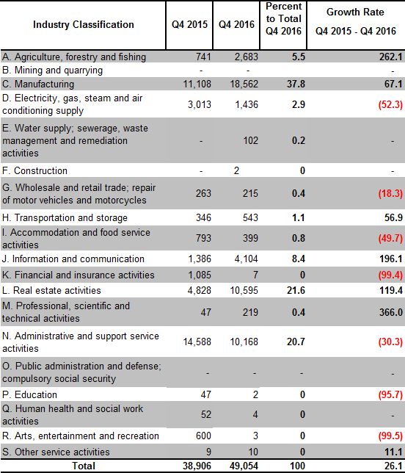

Sources of data: AFAB, BOI, BOI-ARMM, CDC, CEZA, PEZA, SBMA

**B.5.2 Annual 2016**

Out of a total 195,971 projected jobs from prospective ventures of foreign and Filipino investors in 2016, Administrative and Support Service Activities (61,218 jobs or 31.2 percent share), Manufacturing (60,937 jobs or 31.1 percent share) and Real Estate Activities   
(32,838 jobs or 16.8 percent share) were foreseen to supply the bulk of the projected employment. These industries registered year-on-year increases of 19.4 percent, 25.0 percent and 30.5 percent, respectively (Table F).

**Table F**

**Projected Employment from Approved Investments by Industry**

**Annual, 2015 and 2016**

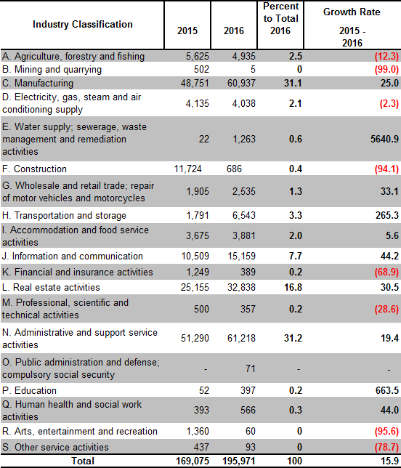

Sources of data: AFAB, BOI, BOI-ARMM, CDC, CEZA, PEZA, SBMA

**C. Approved Investments in the Information and Communications Technology (ICT) Industry**

**C.1 Total Approved FI in ICT**

##### C.1.1 Fourth quarter 2016

Approved ICT foreign investments in Q4 2016 amounted to PhP 14.3 billion, down by   
19.2 percent compared to its level in the previous year. ICT represents 11.4 percent of the foreign investment pledges during the period in review. PEZA had consistently received the bulk of investment pledges in ICT, with 98.4 percent share in Q4 2016. PEZA investments in ICT, however, declined by 12.4 percent to PhP 14.1 billion from PhP 16.1 billion in the previous year (Part II – Table 11a).

# C.1.2 Annual 2016

Potential foreign investments in ICT in the year 2016 increased by 2.6 percent, amounting to   
PhP 29.0 billion from previous year’s PhP 28.2 billion. FI in ICT coursed through PEZA amounted to PhP 28.5 billion, higher by 12.2 percent compared to PhP 25.4 billion a year ago. BOI, on the other hand, registered 74.7 percent decline in FI in ICT during the period in review.

FI in ICT would account for 13.2 percent of the total FI registered in 2016 (Part II – Table 12b).

**C.2 Total Approved Investments in ICT of Foreign and Filipino Nationals**

##### C.2.1 Fourth quarter 2016

Pledges in ICT investments by foreign and Filipino nationals in the fourth quarter of 2016 amounted to PhP 15.3 billion, down by 28.3 percent from PhP 21.4 billion in Q4 2015. Foreign nationals remained as the major source of investment pledges in ICT, committing 93.5 percent of the total investments in ICT in 2016 (Table G and Part II – Table 11a).

**Table G**

**Total Approved Investments in ICT**

**by Foreign and Filipino Nationals (in million pesos)**

**Fourth quarter 2015 and 2016**

|  |  |  |  |  |
| --- | --- | --- | --- | --- |
| Nationality | Q4 2015 | Q4 2016 | Percent to Total Q4 2016 | Growth Rate  Q4 2015 - Q4 2016 |
|
|  |  |  |  |  |
| Foreign | 17,744.4 | 14,338.5 | 93.5 | (19.2) |
| Filipino | 3,639.0 | 994.1 | 6.5 | (72.7) |
|  |  |  |  |  |
| **Total** | **21,383.4** | **15,332.6** | **100.0** | **(28.3)** |

Sources of data: AFAB, BOI, BOI-ARMM, CDC, CEZA, PEZA, SBMA

* 1. **C.2.2 Annual 2016**

Total approved investments in ICT by foreign and Filipino nationals in 2016 dropped by   
22.6 percent to PhP 30.7 billion. The ICT investments by Filipino nationals decreased by   
84.7 percent. Potential investments in ICT by Filipino accounted for 5.7 percent of the total approved projects in ICT (Part II - Table 11b).

**C.3 Total Approved Investments in ICT of Foreign and Filipino nationals by ICT sub-industry**

##### C.3.1 Fourth quarter 2016

IT services remained as the main recipient of investment intentions in ICT of foreign and Filipino nationals during the quarter as it stood to receive PhP 12.4 billion or 81.2 percent of total ICT projects. Information and communication accounted for 18.8 percent or PhP 2.9 billion   
(Part II – Table 13a).

# C.3.2 Annual 2016

Of the total investments in ICT in 2016, 86.8 percent or PhP 26.7 billion would go to IT Services. Information and Communication came in second at PhP 4.1 billion, contributing a share of   
13.2 percent. Meanwhile, Manufacturing and Trade accounted for PhP 8.5 million and   
PhP 1.6 million, respectively (Part II – Table 13b).

**C.4 Projected Employment from Approved Investments in ICT of Foreign and Filipino Nationals by ICT Sub-industry**

**C.4.1 Fourth quarter 2016**

Approved investments of foreign and Filipino nationals in ICT were anticipated to create   
12,025 jobs in the fourth quarter of 2016, lower by 19.1 percent compared to the 14,864 jobs expected in Q4 2015. IT services was expected to supply 10,286 jobs or 85.5 percent of total employment in ICT, while 1,739 jobs were seen to be generated from Information and Communication (Table H and Part II – Table 14a).

Projected employment from ICT sub-industry accounted for 24.5 percent of total jobs expected from the investment projects of foreign and Filipino nationals approved in the fourth quarter of 2016 (Part II – Tables 14a and 10a).

**Table H**

**Projected Employment from Approved Investments in ICT by ICT Sub-industry**

**Fourth quarter 2015 and 2016**

|  |  |  |  |  |
| --- | --- | --- | --- | --- |
| **ICT Sub-industry** | **Projected Employment in ICT** | | **Percent to Total  Q4 2016** | **Growth Rate Q4 2015-  Q4 2016** |
| **Q4 2015** | **Q4 2016** |
|
|  |  |  |  |  |
| Information and communication | 1,396 | 1,739 | 14.5 | **24.6** |
| IT Services | 13,468 | 10,286 | 85.5 | **(23.6)** |
| Manufacturing | - | - | - | **-** |
| Trade | - | - | - | **-** |
| **Total** | **14,864** | **12,025** | **100.0** | **(19.1)** |

Sources of data: AFAB, BOI, BOI-ARMM, CDC, CEZA, PEZA, SBMA

# C.4.2 Annual 2016

Projected employment from ICT projects in 2016 totaled to 71,459 jobs, 19.5 percent higher than 59,786 jobs expected in the same period last year. IT services was anticipated to absorb   
60,889 jobs or 85.2 percent of the projected employment, while Information and Communication was likely to take the remaining 10,570 jobs or 14.8 percent (Part II – Table 14b).

1. **Actual Foreign Direct Investments (FDI) in the Balance of Payments[4]**

**D.1 Total BOP FDI in US Dollars and Philippine Pesos[5]**

**D.1.1 October to November 2016**

As reported by the BSP, net Foreign Direct Investments (FDI) inflows for October to November 2016 reached US$ 1.1 billion, 25.8 percent higher than last year’s record of   
US$ 872.9 million. Equity other than reinvestment of earnings was valued at   
US$ 214.0 million. On the other hand, reinvestment of earnings and net debt instruments respectively amounted to US$ 115.5 million and US$ 769.0 million from October to November 2016 (Part II – Figure 9a and Table 15a).

**Figure 9a**

**Balance of Payments FDI (in million US$)**

**October to November, 2015 and 2016**

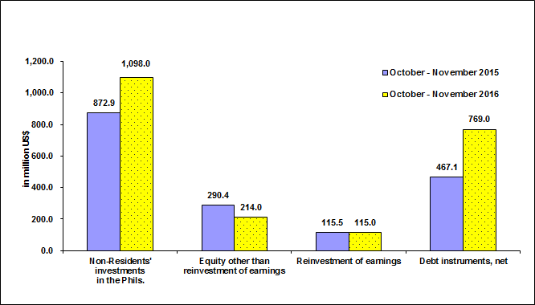

Source of data: BSP

In peso terms, FDI net inflows for the period October to November of 2016 amounted to   
PhP 49.3 billion, 25.8 percent higher compared to PhP 39.2 billion in the preceding year   
(Part II – Table 16a).

**D.1.2 January to November 2016**

Net FDI inflows from January to November of 2016 amounted to US$ 7.0 billion, 25.3 percent lower compared to US$ 5.6 billion recorded in the same period in 2015. Equity other than reinvestment of earnings reached US$ 1.8 billion, 3.4 percent higher compared to   
US$ 1.7 billion in the previous year (Part II – Figure 9b and Table 15b).

Net inflows of reinvestment of earnings amounted to US$ 662.0 million, a decline of   
4.2 percent compared to the previous year. Meanwhile, net debt instruments registered an inflow of US$ 4.5 billion during the period in review.

**Figure 9b**

**Balance of Payments FDI (in million pesos)**

**January to November, 2015 and 2016**



Source of data: BSP

In peso terms, FDI in the BOP for the period January to November 2016 recorded a net inflow of PhP 310.3 billion, higher by 26.0 percent from a net inflow of PhP 246.3 billion in the same period in 2015 (Part II – Table 16b).

1. Approved FI represents the amount of proposed contribution or share of foreigners to various projects in the country as approved and registered by the IPAs. This consists of equity, loans and reinvested earnings. (See Annex A – Technical Notes)
2. FDI refers to actual foreign direct investments in the BOP, with the foreign investors owning 10 percent or more of the ordinary shares or voting power or the equivalent. Data refers to net FDI flows consisting of non-residents’ equity capital placements less non-residents’ equity capital withdrawals plus reinvested earnings plus net intercompany loans.
3. Industry classification is based on the 2009 Philippine Standard Industrial Classification (PSIC).
4. BSP media release dated February 13, 2017
5. Using monthly average buying and selling rates downloaded from BSP website