**Approved Foreign Investments in the Philippines**

# Second Quarter 2015

### Summary

**Total approved foreign investments (FI)**[1]**, Q2 and first semester 2015**

Total foreign investments (FI) approved in the second quarter of 2015 by the seven investment promotion agencies (IPAs), namely: Board of Investments (BOI), Clark Development Corporation (CDC), Philippine Economic Zone Authority (PEZA), and Subic Bay Metropolitan Authority (SBMA) as well as the Authority of the Freeport Area of Bataan (AFAB), BOI-Autonomous Region of Muslim Mindanao (BOI-ARMM), and Cagayan Economic Zone Authority (CEZA) amounted to PhP 36.2 billion, slightly higher by 0.5 percent from PhP 36.0 billion recorded in the same period last year. Meanwhile, total approved FI for the first six months of the year reached PhP 58.0 billion, declining by 21.0 percent from PhP 73.4 billion in the previous year.

The top three prospective investing countries for the second quarter of 2015 include the Netherlands, Singapore and Japan. The Netherlands pledged PhP 17.0 billion or 46.8 percent share during the quarter while Singapore and Japan committed PhP 8.4 billion and PhP 4.0 billion, or 23.2 percent and 11.1 percent of the total approved FI, respectively.

For the first semester of 2015, the same countries belong to the top three, with the Netherlands leading with investment commitments of PhP 18.1 billion or 31.2 percent. Japan and Singapore pledged PhP 11.2 billion or 19.3 percent and PhP 10.0 billion or 17.2 percent, respectively.

Manufacturing has remained to be the industry with the largest amount of committed foreign investments in the second quarter of 2015 at PhP 21.8 billion or 60.2 percent share. Agriculture, forestry and fishing came in second with investment pledges valued at PhP 5.1 billion or 14.2 percent, followed by construction at PhP 2.6 billion or 7.2 percent share.

During the first half of 2015, manufacturing maintained the top post, with commitments of PhP 30.9 billion, accounting for 53.3 percent. This is followed by agriculture, forestry and fishing at PhP 5.1 billion or 8.9 percent and administrative and support service activities at PhP 5.0 billion or 8.7 percent.

About this report

# Inside

# Part I - Analysis

A. Approved foreign investments…………………….... 4 to 14

B. Approved investments of foreign and Filipino nationals……………….. 14 to 21

C. Approved investments in the

Information and Communications Technology (ICT) Industry………………..…….….. 21 to 24

D. Actual foreign direct investments

in the Balance of Payments…… 24 to 26

###### Part II – Statistical Tables

###### Annexes

This report is the 72nd of a series on quarterly statistics on foreign investments (FI) in the Philippines, integrating the quarterly statistical reports on FI submitted by the government’s investments promotion, administration and regulation agencies. It provides an analysis of the:

1. *Foreign investments* (FI)and *investments by Filipinos approved* by the Board of Investments (BOI), Clark Development Corporation (CDC), Philippine Economic Zone Authority (PEZA), Subic Bay Metropolitan Authority (SBMA), Authority of the Freeport Area of Bataan (AFAB), BOI-Autonomous Region of Muslim Mindanao (BOI-ARMM), and Cagayan Economic Zone Authority (CEZA). Approved foreign investments represent investment commitments or pledges by foreigners regardless of the percentage of ownership of the ordinary shares, which may be realized in the near future.
2. *Foreign direct investments* (FDI) in the Balance of Payments (BOP) as compiled by the Bangko Sentral ng Pilipinas (BSP). FDI refers to actual foreign direct investments in the BOP, with the foreign investors owning 10 percent or more of the ordinary shares or voting power or the equivalent.

Notes: (a) Starting with Q3 2013 Report, foreign investments approved and registered by the investment promotion agencies (IPAs) is termed “approved foreign investments,” replacing the term “approved foreign direct investments” used in the previous reports. This is to distinguish clearly the approved foreign investments which are only commitments or pledges from the foreign direct investments (FDI) which are actual investments being compiled by the BSP.

(b) Revisions in the previous quarters’ data are based on the updates provided by the investment promotion agencies.

Annex A presents the technical notes on the data and compilation methodology while Annex B gives a brief background on the Foreign Investment Information System (FIIS) that generates the FI statistics presented in this report.

In terms of location, bulk of the approved foreign investments in the second quarter of 2015 would be intended to finance projects in Region IVA – CALABARZON, amounting to PhP 22.3 billion or 61.5 percent. The next highest investments would be in Region VII – Central Visayas at PhP 3.9 billion or 10.8 percent, followed by the National Capital Region (NCR) at PhP 2.4 billion or 6.6 percent.

For the first semester of 2015, majority of the approved foreign investments would be in Region IVA, valued at PhP 31.4 billion or 54.1 percent share. This is followed by NCR with pledges amounting to PhP 7.9 billion or 13.6 percent and Region III – Central Luzon at PhP 7.3 billion or 12.7 percent.

#### Foreign direct investments (FDI) [2] in the Balance of Payments, Q2 and first semester 2015

Foreign direct investments (FDI) in the Balance of Payments (BOP) as compiled by the Bangko Sentral ng Pilipinas (BSP) recorded net inflows of US$ 1.2 billion for second quarter of 2015. It is 29.6 percent lower than US$ 1.7 billion compared to the same period last year. Meanwhile, net FDI inflows in the first semester of 2015 amounted to US$ 2.0 billion, lower by 40.2 percent from US$ 3.4 billion during the same period in 2014.

In peso terms, FDI in the BOP in the second quarter of 2015 posted a net inflow of PhP 52.2 billion, down by 28.8 percent from PhP 73.2 billion in the same period last year. For the first six months of the year, FDI in the BOP recorded a net inflow of PhP 90.0 billion, posting 40.1 percent decline from a net inflow of PhP 150.3 billion in the same period in 2014.

**Approved investments of foreign and Filipino nationals, Q2 and first semester 2015**

Approved investments of foreign and Filipino nationals reached PhP 90.0 billion in the second quarter of 2015, declining by 65.1 percent from last year’s PhP 257.8 billion. Filipino nationals continued to dominate investments approved during the quarter, sharing 59.8 percent or PhP 53.8 billion worth of pledges. Among the industries, manufacturing would receive the highest investments at PhP 25.4 billion or 28.2 percent of the total approved investments.

For the first semester of 2015, the total approved investments of foreign and Filipino nationals amounted to PhP 186.4 billion, 48.9 percent lower than PhP 365.2 billion committed a year ago. The highest investments would go to real estate activities at PhP 48.8 billion or 26.2 percent of the total approved investments.

**Projected employment from approved investments of foreign and Filipino nationals, Q2 and first semester 2015**

Total projects of foreign and Filipino investors approved by the seven IPAs for the second quarter of 2015 are expected to generate 36,196 jobs, lower by 69.5 percent from last year’s projected employment of 118,835 in the same period. Out of these anticipated jobs, 71.5 percent would come from projects with foreign interest. Among the industries, administrative and support service activities are expected to have the most number of jobs to be generated at 11,752.

For the first semester of the year, projected employment from approved investments reached 81,393 jobs, down by 51.4 percent from the 167,324 jobs expected in the same period a year ago. The most number of jobs expected to be generated would be for the administrative and support service activities at 24,858.

**Approved investments of foreign and Filipino nationals in Information and Communications Technology (ICT), Q2 and first semester 2015**

Investments in information and communications technology (ICT) proposed by foreign and Filipino nationals in Q2 2015 went up by 27.8 percent to PhP 4.6 billion, from PhP 3.6 billion committed in the second quarter of 2014. Share of the projects in ICT stood at 5.1 percent of the total approved investments during the quarter. Foreign nationals remained as the major source of investment pledges in ICT, committing PhP 3.1 billion worth of investments or a share of 67.2 percent.

Proposed investments in ICT for the first six months of the year totaled PhP 13.5 billion, an increase by 45.7 percent from PhP 9.2 billion committed in the first semester of 2014.

**Part I – ANALYSIS**

1. **Approved foreign investments (FI)**

**A.1 Total approved FI**

**A.1.1 Second quarter 2015**

FI applications received and approved in the second quarter of 2015 by BOI, CDC, PEZA, SBMA, AFAB, BOI-BOI-ARMM, and CEZA amounted to PhP 36.2 billion, inching up by 0.5 percent from PhP 36.0 billion recorded in the same period last year.

**Figure 1a**

**Total Approved Foreign Investments**

**Second Quarter, 2014 and 2015**

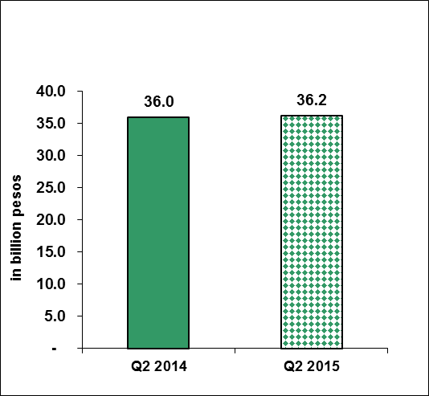

Sources of data: AFAB, BOI, BOI-ARMM, CDC, CEZA, PEZA, SBMA

Among the IPAs, CEZA registered the highest increase as investment pledges reached PhP 345.2 million from PhP 14.4 million in Q2 2014. Approved FI from BOI grew by 61.0 percent, valued at PhP 10.9 billion from PhP 6.8 billion a year ago, while committed investments from SBMA increased by 44.4 percent, from PhP 187.6 billion to PhP 270.8 billion. Investment pledges from PEZA amounted to PhP 24.0 billion, higher by 13.7 percent compared to PhP 21.1 billion a year ago. PEZA’s investments accounts for 66.2 percent of the total approved FI. On the other hand, pledges from AFAB and CDC went down by 93.3 percent and 90.5 percent, respectively (Table A and Part II – Table 1b).

**Table A**

**Total Approved FI by Investment Promotion Agency**

**(in million pesos)**

**Second Quarter, 2014 and 2015**



Sources of data: AFAB, BOI, BOI-ARMM, CDC, CEZA, PEZA, SBMA

**A.1.2 January to June 2015**

Total approved FI for the first six months of the year reached PhP 58.0 billion, declining by 21.0 percent from last year’s PhP 73.4 billion. Bulk of total FI applications at 66.1 percent was coursed through PEZA with pledges amounting to PhP 38.4 billion. BOI and CDC came in second and third, contributing 22.9 percent and 9.2 percent, respectively. AFAB, CEZA, and SBMA jointly accounted for 1.7 percent of the total FI in the first semester of 2015.

**Figure 1b**

**Total Approved Foreign Investments**

**First Semester, 2014 and 2015**

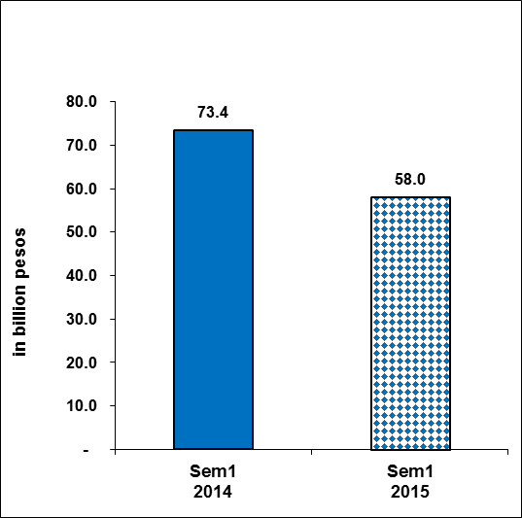

Sources of data: AFAB, BOI, BOI-ARMM, CDC, CEZA, PEZA, SBMA

Investment pledges from CEZA increased by eight folds in the first six months of 2015 while commitments from AFAB and BOI grew by 37.9 percent and 15.9 percent, respectively. On the other hand, investment pledges from CDC, PEZA, and SBMA declined by 32.5 percent, 8.7 percent, and 96.0 percent, respectively (Table B and Part II – Table 1c).

**Table B**

**Total Approved FI by Investment Promotion Agency**

**(in million pesos)**

**First Semester, 2014 and 2015**



Sources of data: AFAB, BOI, BOI-ARMM, CDC, CEZA, PEZA, SBMA

Figure 2 below shows the series of quarterly approved FI from Q1 1996 to Q2 2015.

**Figure 2**

**Total Approved Foreign Investments (in billion pesos)**

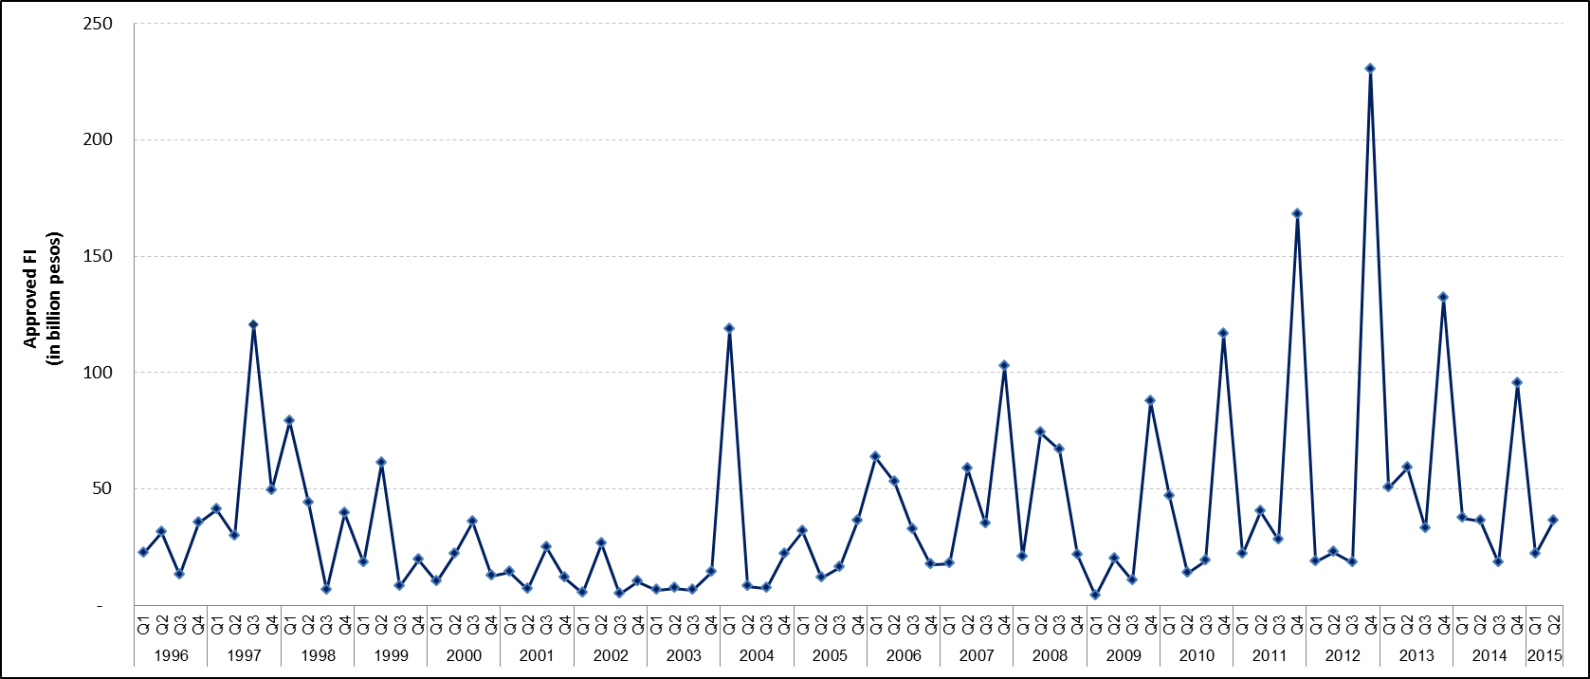**First Quarter 1996 to Second Quarter 2015**

Sources of data: AFAB, BOI, BOI-ARMM, CDC, CEZA, PEZA, SBMA

**A.2 Top prospective investing countries**

**A.2.1 Second quarter 2015**

The Netherlands led the list of top countries as it intended to pour in PhP 17.0 billion worth of investments, accounting for 46.8 percent of the total FI during the second quarter of 2015. Majority of the investments are intended to finance projects in administrative and support service activities and information and communication. Joining the Netherlands as top sources of FI are Singapore, with PhP 8.4 billion investment pledges or a share of 23.2 percent and Japan, cutting in 4.0 percent or PhP 11.1 billion.

Investments pledged from Japan are mostly intended to finance projects in the manufacturing industry while FI from Singapore would fund projects in agriculture, forestry and fishing, construction, and manufacturing (Figure 3a and Part II - Table 2a).

**Figure 3a**

**Total Approved FI by Country of Investor**

**Second Quarter 2015**

.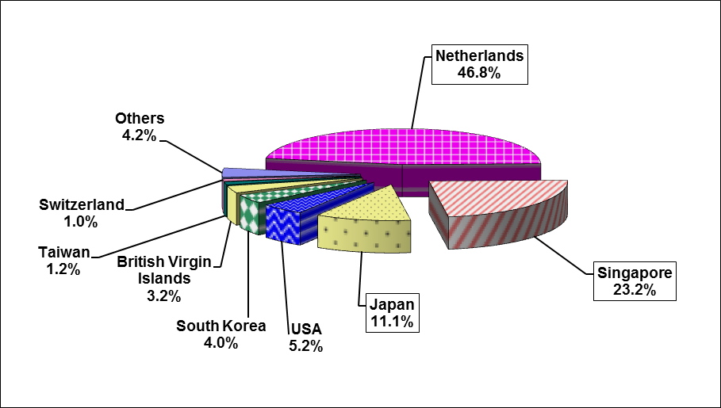

Sources of data: AFAB, BOI, BOI-ARMM, CDC, CEZA, PEZA, SBMA

**A.2.2 January to June 2015**

On a semestral basis, the Netherlands continued to top the list of investing countries, committing PhP 18.1 billion or 31.2 percent of the total FI applications, followed by Japan, sharing PhP 11.2 billion or 19.3 percent, and Singapore, cutting in PhP 10.0 billion or 17.2 percent share. Investments from the Netherlands and Japan were mainly intended to fund projects in manufacturing while most of the investments from Singapore would be in agriculture, forestry, and fishing. Investment pledges from the Netherlands registered an increase of three folds from PhP 5.4 billion in Q2 2014. Meanwhile, the FI applications from Japan grew by 0.7 percent during the period while commitments from Singapore declined by 17.0 percent (Figure 3b and Part II – Table 2b).

**Figure 3b**

**Total Approved FI by Country of Investor**

**First Semester 2015**

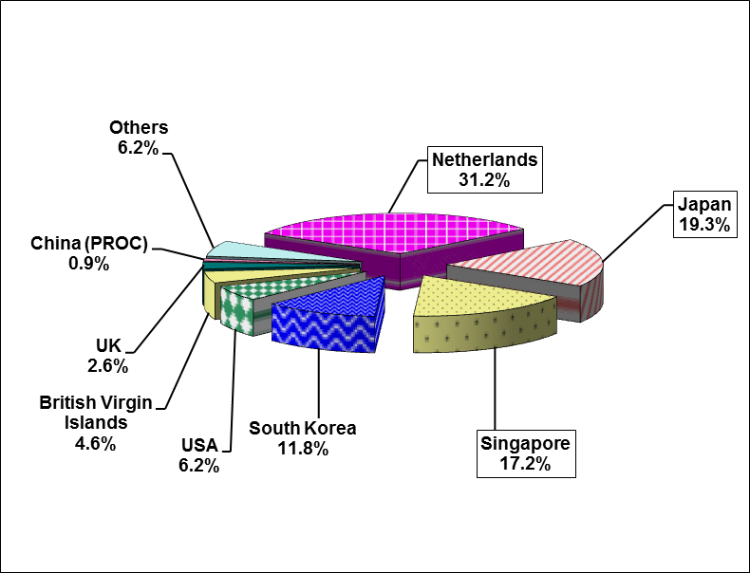

Sources of data: AFAB, BOI, BOI-ARMM, CDC, CEZA, PEZA, SBMA

**A.3 Top industries for approved foreign investments**

**A.3.1 Second quarter 2015**

The hefty investments worth PhP 21.8 billion intended to fund projects in manufacturing placed it at the top post, with a share of 60.2 percent. The amount is 17.6 percent higher than PhP 18.5 billion committed to the industry in Q2 2014. Trailing far behind are agriculture, forestry and fishing, with investments valued at PhP 5.1 billion or 14.2 percent and construction at PhP 2.6 billion, accounting for 7.2 percent of the total FI. During the period, investments in agriculture, forestry and fishing and construction both went up by around 20 folds (Table C and Part II – Table 3a).

**Figure 4a**

**Total Approved FI by Industry**

**Second Quarter 2015**

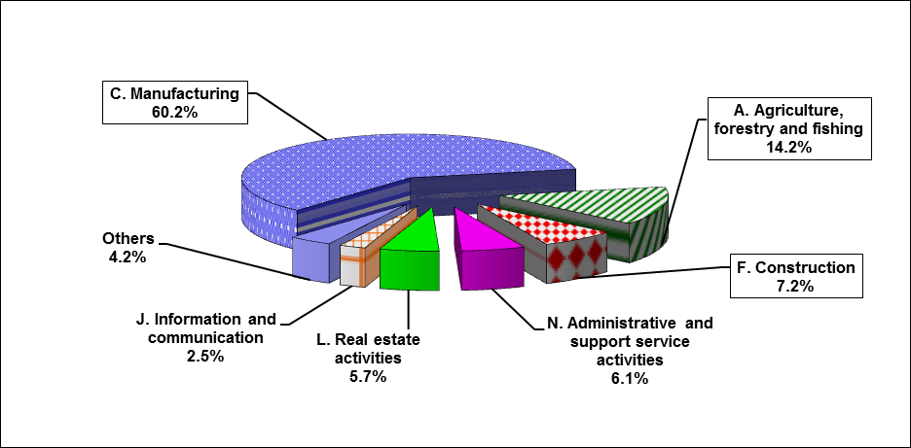

Sources of data: AFAB, BOI, BOI-ARMM, CDC, CEZA, PEZA, SBMA

**Table C**

**Total Approved FI by Industry[3] (in million pesos)**

**Second Quarter, 2014 and 2015**



Sources of data: AFAB, BOI, BOI-ARMM, CDC, CEZA, PEZA, SBMA

**A.3.2 January to June 2015**

Majority of the foreign investment commitments in the first semester of 2015 were intended to finance projects in the manufacturing industry. Manufacturing stands to receive PhP 30.9 billion or 53.3 percent share of the total approved FI. Pledges in the said industry, however, declined by 33.2 percent from PhP 46.3 billion in the first semester of 2014. Agriculture, forestry, and fishing came in second with investment commitments valued at PhP 5.1 billion or 8.9 percent, followed by administrative and support service activities at PhP 5.0 billion or 8.7 percent share. Proposed investments in agriculture, forestry, and fishing grew by around 27 folds in the first semester of 2015 while FI for administrative and support service activities declined by 29.1 percent (Table D and Part II – Table 3b).

**Figure 4b**

**Total Approved FI by Industry**

**First Semester 2015**

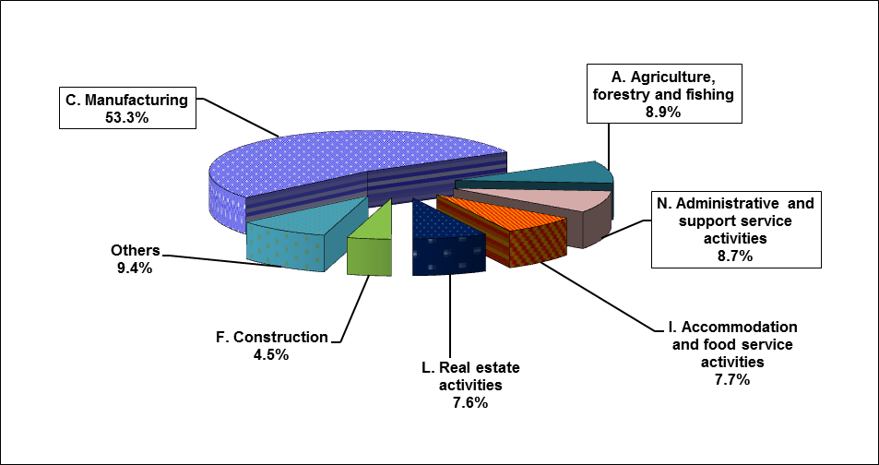

Sources of data: AFAB, BOI, BOI-ARMM, CDC, CEZA, PEZA, SBMA

**Table D**

**Total Approved FI by Industry[4] (in million pesos)**

**First Semester, 2014 and 2015**



Sources of data: AFAB, BOI, BOI-ARMM, CDC, CEZA, PEZA, SBMA

**A.4. Total approved FI by region**

**A.4.1 Second Quarter 2015**

Bulk of the approved foreign investments in the second quarter of 2015 would be intended to finance projects located in Region IVA - CALABARZON. FI pledges that would fund projects in the said region amounts to PhP 22.3 billion or 61.5 percent of the total FI. Foreign investments in Region IVA grew by 25.9 percent compared to same period last year at PhP 17.7 billion. The regions with the second and third largest amount of investments for Q2 2015 were Region VII – Central Visayas with PhP 3.9 billion or 10.8 percent and the National Capital Region (NCR) with PhP 2.4 billion or 6.6 percent of the total FI (Table E and Part II – Table 4a).

Majority of the investments in Region IVA are intended for projects in manufacturing and information and communication. For Region VII, the ventures would be mostly in construction while for NCR, most of the prospective projects would be in administrative and support service, real estate, and professional, scientific and technical activities.

**Table E**

**Total Approved FI by Region (in million pesos)**

**Second Quarter, 2014 and 2015**



Sources of data: AFAB, BOI, BOI-ARMM, CDC, CEZA, PEZA, SBMA

**A.4.2 January to June 2015**

Region IVA – CALABARZON is set to receive majority of the foreign investment commitments in the first semester of 2015, in the amount of PhP 31.4 billion or 54.1 percent of the total FI. Investment commitments intended for the region, however, dipped by 4.4 percent in the first six months of the year. The second largest amount of FI in the first semester is intended for the National Capital Region (NCR), accounting for 13.6 percent or PhP 7.9 billion. Meanwhile, Region III – Central Luzon posted the third largest share of FI at PhP7.3 billion, 12.7 percent of the total approved investments. FI approvals for NCR and Region III also exhibited declines at 44.9 percent and 64.0 percent, respectively, compared to the previous year (Table F and Part II – Table 4b).

Majority of the investments in Region IVA and Region III are intended for projects in manufacturing and real estate. For NCR, the ventures would be mostly in administrative and support service activities and real estate.

**Table F**

**Total Approved FI by Region (in million pesos)**

**First Semester, 2014 and 2015**

~~~~

Sources of data: AFAB, BOI, BOI-ARMM, CDC, CEZA, PEZA, SBMA

**A.5 Projected employment from approved FI**

**A.5.1 Second Quarter 2015**

FI projects approved by the seven IPAs in the second quarter of 2015 are expected to generate 25,869 jobs, 76.5 percent lower than 110,070 prospective jobs in the same period last year (Part II – Table 5a). Foreign investments coursed through PEZA are expected to generate the most number of jobs at 17,892 accounting for 69.2 percent of the total projected employment for the quarter. BOI-approved FI projects accounted for 5,866 jobs or 22.7 percent while projects approved by CDC accounted for 1,582 jobs or 6.1 percent share. The other IPAs had minimal share of less than one percent in terms of job generation.

For the second quarter of 2015, only CEZA registered an increase in the number of expected jobs, at 61.7 percent. Projected employment for AFAB and CDC exhibited the highest decline at 98.5 percent and 97.9 percent, respectively. Meanwhile, projected employment from projects approved by PEZA, BOI, and SBMA went down by 18.8 percent, 25.3 percent, and 19.1 percent, respectively.

The industries which are expected to generate the most number of jobs are administrative and support service activities at 11,410, manufacturing at 8,429 and information and communication at 2,245 jobs.

**A.4.2 January to June 2015**

Projected employment from approved FI during the first half of 2015 stood at 49,801 jobs, around one-third of the 148,249 jobs expected to be generated from the FI investments committed in the same period last year. FI projects approved by PEZA are expected to generate the most number of jobs at 38,668 or 77.6 percent of the total projected employment, followed by BOI with 6,066 jobs or 12.2 percent and CDC with 4,053 jobs or 8.1 percent.

All the IPAs recorded a decline in their projected employment in the first semester of 2015, with the exception of CEZA, which registered a 107.4 percent increase in prospective jobs. In terms of industries, administrative and support service activities is expected to generate the highest number of jobs at 23,283, followed by manufacturing at 18,850 and information and communication at 3,016 jobs.

**B. Approved investments of foreign and Filipino nationals**

**B.1 Total approved investments of foreign and Filipino nationals**

**B.1.1 Second quarter 2015**

Approved investments of Filipino and foreign nationals declined by 65.1 percent to PhP 90.0 billion, from PhP 257.8 billion registered in the second quarter of 2014. Filipino nationals accounted for majority of the investments approved during the quarter, supplying 59.8 percent or PhP 53.8 billion. This is, however, 75.8 percent lower compared with the pledges placed a year ago (Figure 5a and Part II - Table 6a).

The bulk of the investment commitments of foreign and Filipino nationals for the quarter were coursed through the BOI and PEZA with a combined share of 90.5 percent. Approved investments coursed through the BOI amounted to PhP 37.4 billion, 63.6 percent lower than PhP 102.7 billion approved a year ago. Investment pledges coursed through PEZA, which accounts for 48.9 percent of the total investments in the second quarter, amounted to PhP 44.0 billion, declining by 27.9 percent from PhP 61.1 billion in same period last year. The other IPAs, except for CEZA and SBMA, also registered declines in total investment pledges in the second quarter of 2015. Investment commitments coursed through CEZA jumped to PhP 5.0 billion from PhP 29.7 million in the same period last year, while pledges approved by SBMA grew by 85.5 percent (Part II - Table 6a).

**Figure 5a**

**Total Approved Investments of Foreign and Filipino Nationals**

**Q2 2014 and Q2 2015**

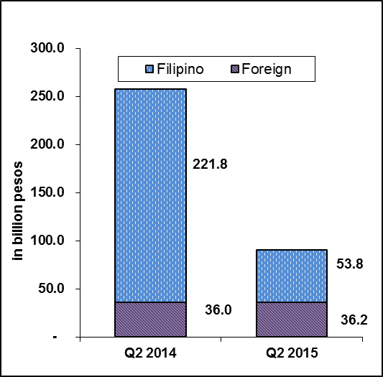

Sources of data: AFAB, BOI, BOI-ARMM, CDC, CEZA, PEZA, SBMA

During the period, the share of Filipino investments to the total approved investments was 59.8 percent while the share of the foreign nationals was 40.2 percent (Part II - Table 7a).

**B.1.2 January to June 2015**

Investment commitments from both foreign and Filipino nationals amounted to PhP 186.4 billion during the first six months of 2015, decreasing by 48.9 percent from PhP 365.2 billion. Of the total amount for the semester, 68.9 percent of the approved investments came from Filipino investors with PhP 128.4 billion worth of pledges (Figure 5b and Part II – Table 6b).

Investment pledges coursed through BOI from January to June 2015 accounted for 49.4 percent of the total investments in the amount of PhP 92.0 billion. Investment commitments through PEZA, with 42.3 percent share totaled PhP 78.9 billion while investments approved by CDC and CEZA accounted for 3.8 percent or PhP 7.1 billion and 2.8 percent or PhP 5.2 billion, respectively. The other IPAs had collective pledges of PhP 3.3 billion or 1.7 percent of the total investments for the semester.

Share of investments of Filipino nationals to the total approved investment was 68.9 percent while share of foreign nationals was 31.1 percent (Part II – Table 7b).

**Figure 5b**

**Total Approved Investments of Foreign and Filipino Nationals**

**Sem1 2014 and Sem1 2015**

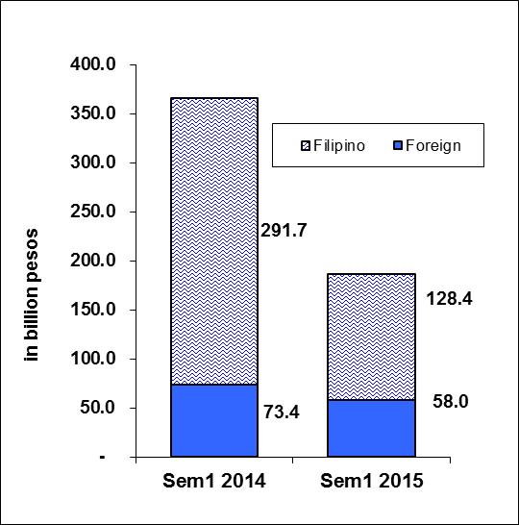

Sources of data: AFAB, BOI, BOI-ARMM, CDC, CEZA, PEZA, SBMA

**B.2 Total approved investments of foreign and Filipino nationals by industry**

**B.2.1 Second quarter 2015**

Manufacturing topped the list of industries during the second quarter of 2015 as it stands to receive PhP 25.4 billion or 28.2 percent of the total investment pledges of foreign and Filipino nationals (Figure 6a and Part II - Tables 3a and 8a).

Investments in real estate activities ranked second as it accounted for 26.1 percent share or PhP 23.5 billion, followed by accommodation and food services, receiving 9.9 percent or PhP 8.9 billion (Figure 6a and Part II – Table 8a).

Figure 6a

Total Approved Investments of Foreign and Filipino Nationals, by Industry

**Second Quarter 2015**

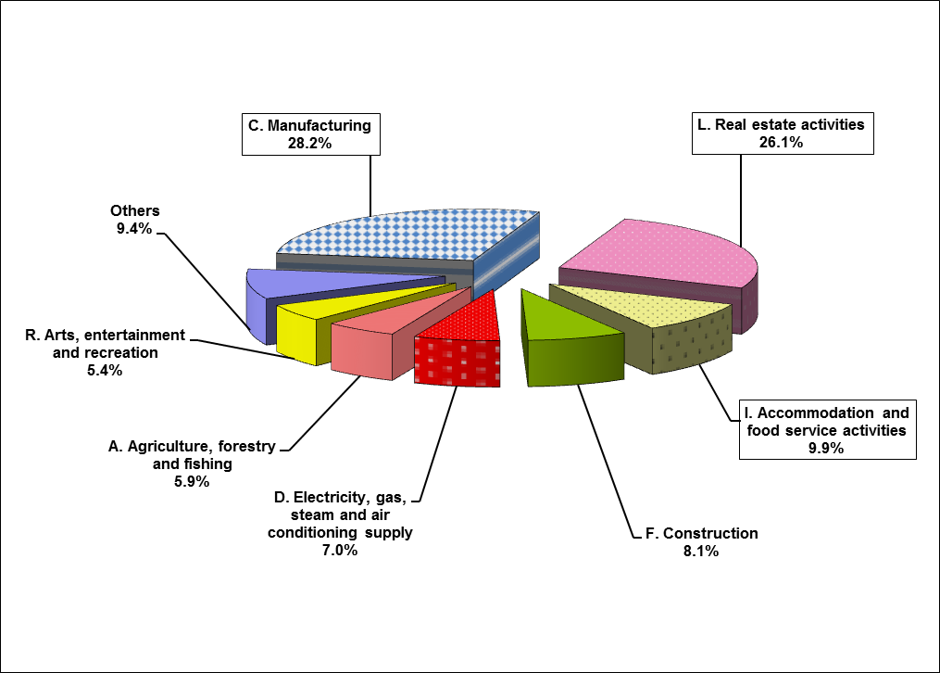

Sources of data: AFAB, BOI, BOI-ARMM, CDC, CEZA, PEZA, SBMA

**B.2.2 January to June 2015**

Topping the list of recipients of investment intentions from both foreign and Filipino nationals during the first half of 2015 are real estate activities in the amount of PhP 48.8 billion or 26.2 percent of total investments. Manufacturing came in second at PhP 48.0 billion or 25.8 percent share, followed by electricity, gas, steam, and air conditioning supply at PhP 20.5 billion or 11.0 percent. Potential investments in these industries, however, declined from their year-ago levels: real estate by 27.6 percent, manufacturing by 12.7 percent, and electricity, gas, steam, and air conditioning supply by 88.5 percent (Figure 6b and Part II – Table 8b).

**Figure 6b**

Total Approved Investments of Foreign and Filipino Nationals, by Industry

**First Semester 2015**

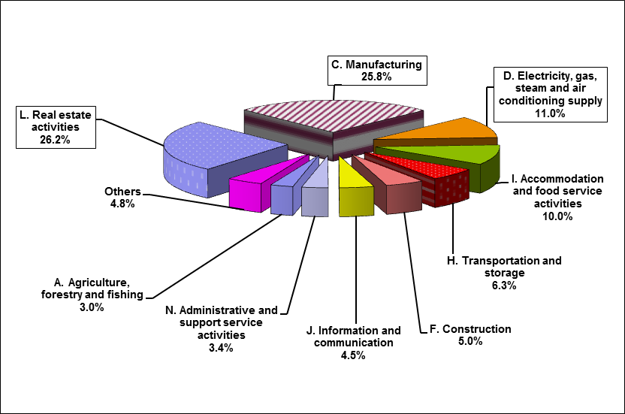

Sources of data: AFAB, BOI, BOI-ARMM, CDC, CEZA, PEZA, SBMA

**B.3. Total approved investments of foreign and Filipino Nationals by region**

**B.3.1 Second quarter 2015**

Bulk of the approved investments from foreign and Filipino nationals in the second quarter of 2015 would be intended to finance projects located in Region IVA - CALABARZON. Total investment pledges for the said region amounts to PhP 39.2 billion, or 43.6 percent of the total FI. However, foreign investments in Region IVA declined by 56.7 percent compared to same period last year at PhP 90.6 billion. The regions with the second and third largest amount of investments for Q2 2015 were the National Capital Region (NCR) with PhP 13.5 billion or 15.0 percent and Region VII – Central Visayas with PhP 9.1 billion or 10.1 percent (Table G and Part II – Table 9a).

Majority of the investments in Region IVA are intended for projects in real estate and electricity, gas, steam and air conditioning supply. For NCR, the ventures would be mostly in real estate activities, accommodation and food service activities, and transportation and storage. Meanwhile, for Region VII most of the prospective projects would be in electricity, gas, steam and air conditioning supply.

**Table G**

**Total Approved Investments of Foreign and Filipino Nationals by Region (in million pesos)**

**Second Quarter, 2014 and 2015**



Sources of data: AFAB, BOI, BOI-ARMM, CDC, CEZA, PEZA, SBMA

**B.3.2 January to June 2015**

Region IVA – CALABARZON stands to receive the largest amount of investments from foreign and Filipino nationals in the first half of 2015. Total investments pledged to Region IVA amounts to PhP 62.8 billion or 33.7 percent of the total investments. However, investment commitments intended for the region declined by 47.3 percent during the period. The National Capital Region (NCR) received the second largest amount of total investment pledges in the first semester, accounting for 20.0 percent or PhP 37.3 billion while Region III – Central Luzon received the third largest share of commitments at 10.6 percent of the total investment pledges. FI approvals for NCR and Region III also registered declines, at 51.5 percent and 82.7 percent, respectively (Table H and Part II – Table 9b).

Majority of the investments in Region IVA are intended for projects in electricity, gas, steam and air conditioning supply and real estate. For NCR and Region III, the ventures would be mostly in real estate activities.

**Table H**

**Total Approved Investments of Foreign and Filipino Nationals by Region (in million pesos)**

**First Semester, 2014 and 2015**



Sources of data: AFAB, BOI, BOI-ARMM, CDC, CEZA, PEZA, SBMA

**B.3 Projected employment from approved investments of foreign and Filipino nationals**

**B.3.1 Second quarter 2015**

Total projects of foreign and Filipino investors approved by the seven IPAs for the second quarter of 2015 are expected to generate 36,196 jobs, a decline of 69.5 percent from last year’s projected employment of 118,835 in the same period. Out of these anticipated jobs, 71.5 percent would come from projects with foreign interest.

**Figure 7a**

**Projected Employment**

**Q2 2014 and Q2 2015**

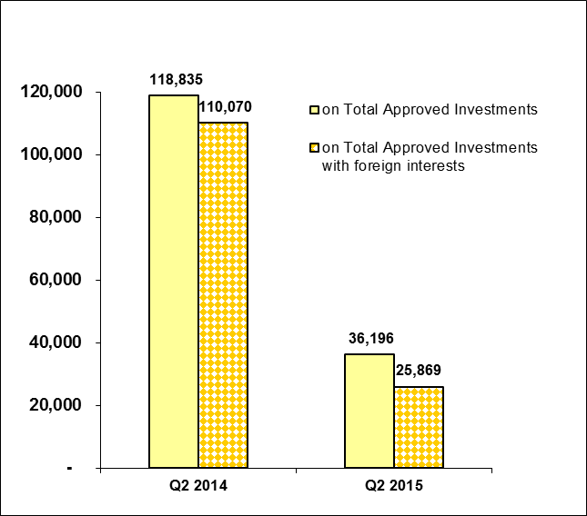

Sources of data: AFAB, BOI, BOI-ARMM, CDC, CEZA, PEZA, SBMA

Projects registered through PEZA posted the largest number of projected employment at 18,798, contributing 51.9 percent of the total expected jobs for the period. BOI-approved projects recorded 13,738 potential jobs, with a share of 38.0 percent while pledges coursed through CDC are expected to generate 2,764 jobs or 7.6 percent. Meanwhile, the combined investments from AFAB, BOI-ARMM, CEZA, and SBMA are expected to generate 896 jobs (Part II – Table 10a).

**B.3.2 January to June 2015**

For the first six months of 2015, a total of 81,393 jobs are expected to be generated from approved investments of foreign and Filipino nationals, 51.4 percent lower compared to 167,324 jobs last year. Around 50.9 percent or 41,457 jobs would come from investment pledges coursed through PEZA followed by BOI with 31,912 jobs which represents 39.2 percent of the total projected employment. Other IPAs would have a combined share of 9.9 percent of the total jobs expected (Part II – Table 10b).

The number of potential jobs expected from foreign and Filipino ventures increased for investments coursed through CEZA and BOI, growing by 102.2 percent and 23.7 percent, respectively. Projected employment declined for the rest of the IPAs during the period.

**Figure 7b**

**Projected Employment**

**First Semester, 2014 and 2015**

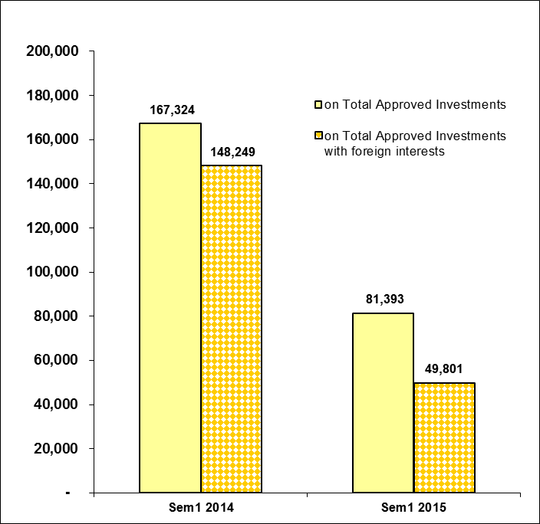

Sources of data: AFAB, BOI, BOI-ARMM, CDC, CEZA, PEZA, SBMA

The number of potential jobs expected from foreign and Filipino ventures during the period increased for investments coursed through CEZA and BOI, growing by 102.2 percent and 23.7 percent, respectively. Projected employment declined for the rest of the IPAs in the first half.

**B.4 Projected employment from approved investments of foreign and Filipino nationals by industry**

**B.4.1 Second quarter 2015**

In terms of projected employment by industry, the administrative and support service activities is expected to have the most number of jobs to be generated at 11,752 in the second quarter of 2015. Projected employment for the said industry grew by 8.7 compared to last year’s employment. Second is the manufacturing industry which is expected to generate 9,776 jobs, lower by 27.0 percent compared to second quarter of 2014. Next is real estate activities which is expected to generate 7,792 jobs (Table I).

**Table I**

**Projected Employment from Approved Investments by Industry**

**Second Quarter, 2014 and 2015**



Sources of data: AFAB, BOI, BOI-ARMM, CDC, CEZA, PEZA, SBMA

**B.4.2 January to June 2015**

Of the 81,393 projected jobs in the first semester of 2015 from prospective ventures of foreign and Filipino investors, administrative and support service activities (24,858 jobs), manufacturing (22,313 jobs), and real estate activities (11,893 jobs) are foreseen to supply the bulk of projected employment with shares of 30.5 percent, 27.4 percent, and 14.5 percent, respectively. The rest of the potential jobs, totaling 22,391 jobs or 27.5 percent, are expected to be provided by the other industries (Table J).

**Table J**

**Projected Employment from Approved Investments by Industry**

**First Semester, 2014 and 2015**



Sources of data: AFAB, BOI, BOI-ARMM, CDC, CEZA, PEZA, SBMA

**C. Approved investments in the Information and Communications Technology (ICT) Industry**

**C.1 Total approved FI in ICT**

##### C.1.1 Second quarter 2015

Approved foreign investments in the ICT in the second quarter of 2015 amounted to PhP 3.1 billion, lower by 9.5 percent compared to the previous year. ICT represents 8.6 percent of the foreign investment pledges during the period. PEZA consistently receives the bulk of investment pledges in ICT, with a share of 80.3 percent during the period. However, PEZA investments in ICT declined by 13.0 percent to PhP 2.5 billion, from PhP 2.8 billion in the previous year. (Part II – Table 11a).

# C.1.2 January to June 2015

Potential foreign investments in ICT in the first six months of 2015 decreased by 21.4 percent, amounting to PhP 6.2 billion from previous year’s PhP 7.9 billion. FI in ICT coursed through PEZA amounted to PhP 5.3 billion, lower by 26.4 percent compared to PhP 7.2 billion a year ago. Likewise, BOI and CDC registered declines in FI in ICT at 38.0 percent and 12.5 percent, respectively, during the period. On the other hand, ICT investments from CEZA and SBMA increased by 752.2 percent and 199.1 percent, respectively. (Part II – Table 11b).

FI in ICT would account for 10.7 percent of the total FI registered in January to June 2015 (Part II – Tables 10b and 11b).

**C.2 Total approved investments in ICT of foreign and Filipino nationals**

##### C.2.1 Second quarter 2015

Pledges in ICT investments made by foreign and Filipino nationals in the second quarter of 2015 amounted to PhP 4.6 billion, up by 27.8 percent from PhP 3.6 billion in Q2 2014. Foreign nationals remained as the major source of investment pledges in ICT, committing 67.2 percent or PhP 3.1 billion worth of investments. But this decreased by 9.5 percent compared to the previous year. Filipino investors, on the other hand, committed PhP 1.5 billion or 32.8 percent of the total ICT investments (Table K and Part II – Table 11a).

**Table K**

**Total Approved Investments in ICT by Foreign and Filipino Nationals**

**Second Quarter 2014 and 2015**

**(in million pesos)**



Sources of data: AFAB, BOI, BOI-ARMM, CDC, CEZA, PEZA, SBMA

* 1. **C.2.2 January to June 2015**

Overall ICT investments made by foreign and Filipino nationals during the first six months of the year increased by 45.7 percent to PhP 13.5 billion from last year’s pledges of PhP 9.2 billion (Part II - Table 11b). Foreign investments in ICT declined by 21.4 percent while ICT investments from Filipino nationals grew by 435.5 percent. Potential investments in ICT by Filipino nationals amounted to PhP 7.3 billion, accounting for 54.0 percent of the total approved projects in ICT (Part II - Tables 11b and 5b).

**C.3 Total approved investments in ICT of foreign and Filipino nationals by ICT sub-industry**

##### C.3.1 Second quarter 2015

IT services remained as the main recipient of investment intentions in ICT of foreign and Filipino nationals during the quarter as it stands to receive PhP 2.7 billion or 57.5 percent of total ICT projects. Information and communication accounted for 42.0 percent or PhP 1.9 billion while investments in trade amounted to PhP 24.0 million. Investments in IT Services declined by 9.7 percent while investments in information and communication grew by 188.2 percent (Part II – Table 13a).

# C.3.2 January to June 2015

Of the PhP 13.5 billion committed by foreign and Filipino investors to fund projects in ICT during the first semester of 2015, 52.5 percent or PhP 7.1 billion would go to information and communication. IT services came in second at PhP 6.4 billion, contributing a share of 47.3 percent. (Part II – Table 13b).

**C.4 Projected employment from approved investments in ICT of foreign and Filipino nationals by ICT sub-industry**

**C.4.1 Second quarter 2015**

Approved investments of foreign and Filipino nationals in ICT are anticipated to create 14,135 jobs in the second quarter of 2015, inching up by 0.9 percent compared to the 14,014 jobs expected in Q2 2014. IT services is expected to supply 11,744 jobs or 83.1 percent of total employment in ICT while 2,382 jobs are seen to be generated from information and communication (Table L and Part II – Table 14a).

Projected employment from ICT sub-industry accounted for 39.1 percent of total jobs expected from the investment projects of foreign and Filipino nationals approved in the second quarter of 2015 (Part II – Tables 14a and 10a).

**Table L**

**Projected Employment from Approved Investments in ICT by ICT Sub-industry**

**Second Quarter 2014 and 2015**



Sources of data: AFAB, BOI, BOI-ARMM, CDC, CEZA, PEZA, SBMA

# C.4.2 January to June 2015

Projected employment from ICT projects in the first six months of the year totaled 28,671 jobs, 4.4 percent higher than 27,457 jobs expected in the same period last year. IT services is expected to absorb 24,829 jobs or 86.6 percent of the expected employment while 3,833 jobs or 13.4 percent would be from information and communication (Part II – Table 14b).

1. **Actual foreign direct investments (FDI) in the Balance of Payments[5]**

**D.1 Total BOP FDI in US dollars and Philippine pesos[6]**

**D.1.1 Second Quarter 2015**

Foreign direct investments (FDI) in the Balance of Payments (BOP) as compiled by the Bangko Sentral ng Pilipinas (BSP) recorded a net inflow of US$ 1.2 billion in the second quarter of 2015, 29.6 percent lower compared to US$ 1.7 billion in the same period a year ago. Equity other than reinvestment of earnings was at US$ 399.0 million. On the other hand, reinvestment of earnings and net debt instruments recorded US$ 200.0 million and US$ 569.0 million, respectively, during the period (Part II – Table 15a).

**Figure 8a**

**Balance of Payments FDI (in million US$)**

**Q2 2014 and Q2 2015**

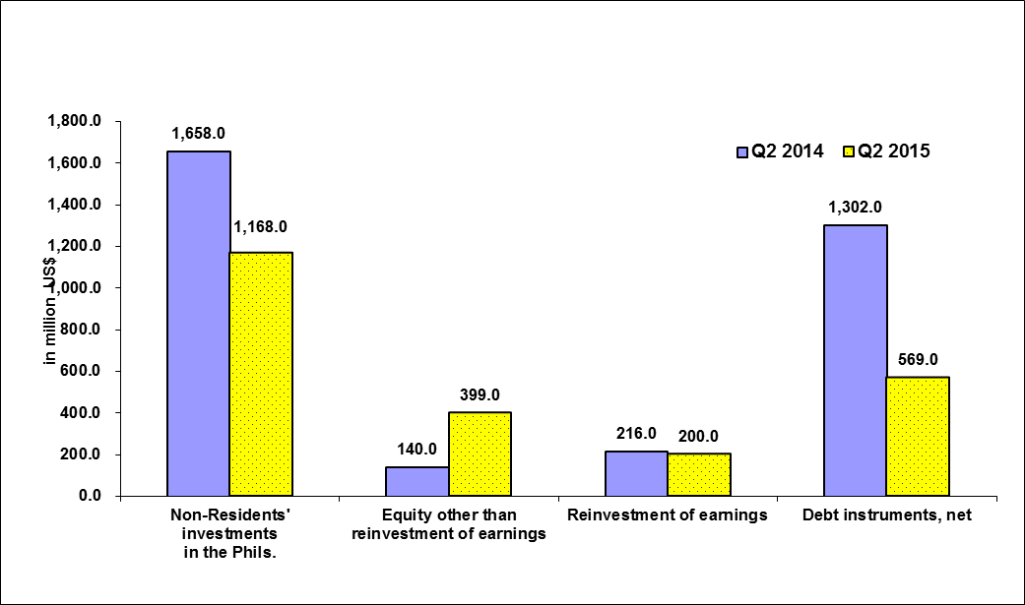

Source of data: BSP

In peso terms, FDI net inflows for the second quarter of 2015 amounted to PhP 52.2 billion, 28.8 percent lower compared to PhP 73.2 billion in the same period last year (Part II – Table 16a).

**D.1.2 January to June 2015**

As reported by the BSP, net FDI inflows from January to June of the year amounted to US$ 2.0 billion, 40.2 percent lower compared to US$ 3.4 billion recorded in the same period in 2014. Equity other than reinvestment of earnings during the period reached US$ 653.0 million, down by 5.8 percent in the previous year (Part II – Table 15b).

Net inflows of reinvestment of earnings reached US$ 385.0 million, a decline by 18.4 percent compared to the previous year. Meanwhile, net debt instruments registered an inflow of US$ 981.0 million during the period.

**Figure 8b**

**Balance of Payments FDI (in million US$)**

**First Semester, 2014 and 2015**

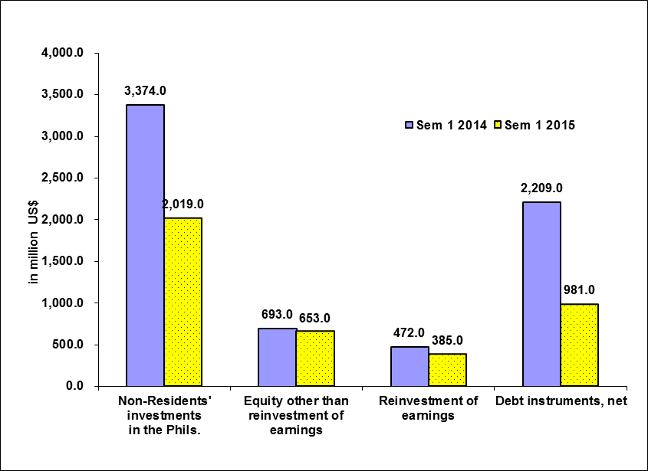

Source of data: BSP

In peso terms, FDI in the BOP for January to June 2015 recorded a net inflow of PhP 90.0 billion, declining by 40.1 percent from a net inflow of PhP 150.0 billion in the same period last year (Part II – Table 16b).

1. Approved FI represents the amount of proposed contribution or share of foreigners to various projects in the country as approved and registered by the IPAs. This consists of equity, loans and reinvested earnings. (See Annex A – Technical Notes)
2. FDI refers to actual foreign direct investments in the BOP, with the foreign investors owning 10 percent or more of the ordinary shares or voting power or the equivalent. Data refers to net FDI flows consisting of non-residents’ equity capital placements less non-residents’ equity capital withdrawals plus reinvested earnings plus net intercompany loans.
3. Industry classification is based on the 2009 Philippine Standard Industrial Classification (PSIC).
4. Industry classification is based on the 2009 Philippine Standard Industrial Classification (PSIC).
5. BSP media release dated September 10, 2015
6. Using monthly average buying and selling rates downloaded from BSP website