Total Health Expenditure
Total health expenditure up by 9.4 percent in 2005
Total health expenditure of the country reached P180.8 billion in 2005, growing at a slower rate of 9.4 percent compared to 11.9 percent growth in 2004.
In real terms, total health expenditure went up by 4.7 percent, growing slower than the previous year's 6.9 percent growth.

ITEM | 2004 ^{1/} | 2005
Total Health Expenditure  (in billion pesos, at current prices) | 165.3 | 180.8
Total Health Expenditure Growth Rate (%)  at current prices | 11.9 | 9.4
Total Health Expenditure ^{2/}  (in billion pesos, at constant 1985 prices) | 41.3 | 43.2
Total Health Expenditure Growth Rate (%)  at constant 1985 prices | 6.9 | 4.7
1/ revised
2/ Derived using the consumer price index (CPI) for all items
Source: National Statistical Coordination Board

Per capita health spending increases
With the total health expenditure growing faster than the population, per capita health spending increased by P142 or a 7.2 percent growth.
In real terms, per capita health spending increased by 2.6 percent in 2005, but moving slower than the 4.7 percent growth in 2004.

ITEM | 2004 ^{1/} | 2005
Per Capita Health Expenditure  (in pesos, at current prices) | 1,978 | 2,120
Per Capita Health Expenditure ^{2/}  (in pesos, at constant 1985 prices) | 494 | 507
Population (million) ^{3/} | 83.6 | 85.3
Population Growth Rate (%) | 2.1 | 2.0
Per Capita Health Expenditure (at current prices) Growth Rate (%) | 9.7 | 7.2
Per Capita Health Expenditure  (at constant 1985 prices)  Growth Rate (%) | 4.7 | 2.6
1/ Revised
2/ Derived using the consumer price index (CPI) for all items
3/ Based on 2000 Census-based population projections, NSO
Source: National Statistical Coordination Board

Share of health expenditure to GDP goes down
The share of health expenditure to GDP was lower at 3.3% in 2005. It is still below the 5 percent standard set by the World Health Organization (WHO) for developing countries. On the other hand, the share of health expenditure to GNP remained at 3.1 percent which is within the National Objectives for Health (NOH) target of 3-4 percent.
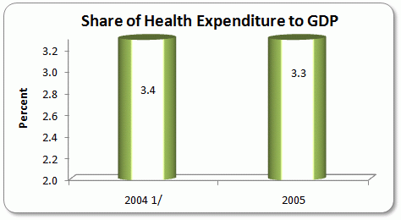
1/ Revised
Source: National Statistical Coordination Board

