QUARTERLY ECONOMIC INDICES
(1978=100)
Growth Rates
(in percent)

Q3 2017
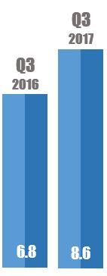
Private Services
Trade

Real Estate
Transportation & Communications
Manufacturing
12.6
8.9
9.4
8.8
8.5
4.1
Finance

Quarterly Indices on
Gross Revenue

Trade
Real Estate
Private Services
Transportation & Communications
Manufacturing

Electricity & Water
Finance
3.1
3.0

2.5
2.1
1.1
1.0
0.8

0.1

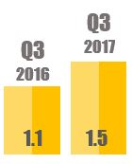
1.1
1.1

Quarterly Indices on
Employment
Mining & Quarrying
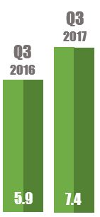
11.3
5.8
14.9
6.5
4.3
8.8
Finance
Transportation & Communication
Electricity & Water
Real Estate
Manufacturing
Trade
Mining & Quarrying
Private Services

Quarterly Indices on
Compensation
5.9
2.2
(1.9)

The Quarterly Economic Indices (QEI) is a compilation of quarterly indices on production, gross revenue, employment, compensation, production per worker, compensation per employee, and average earnings.

Source: Macroeconomic Accounts Service
Philippine Statistics Authority

